LAB 6

Task 1

In this task, we have to setup the lab environment and test a few cases to see if it is running correctly. Here is the lab setup –

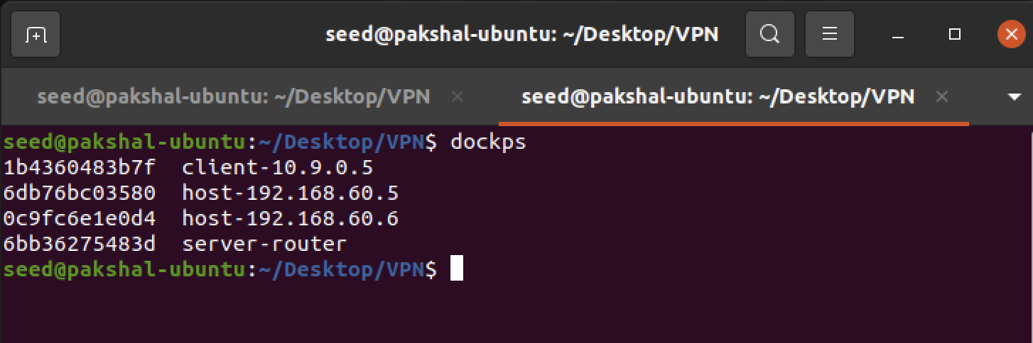

The following tests are run to ensure that the lab environment is set up correctly:

* Host U can communicate with VPN Server.

We docksh into host U (10.9.0.5) and ping the server (10.9.0.11) as shown

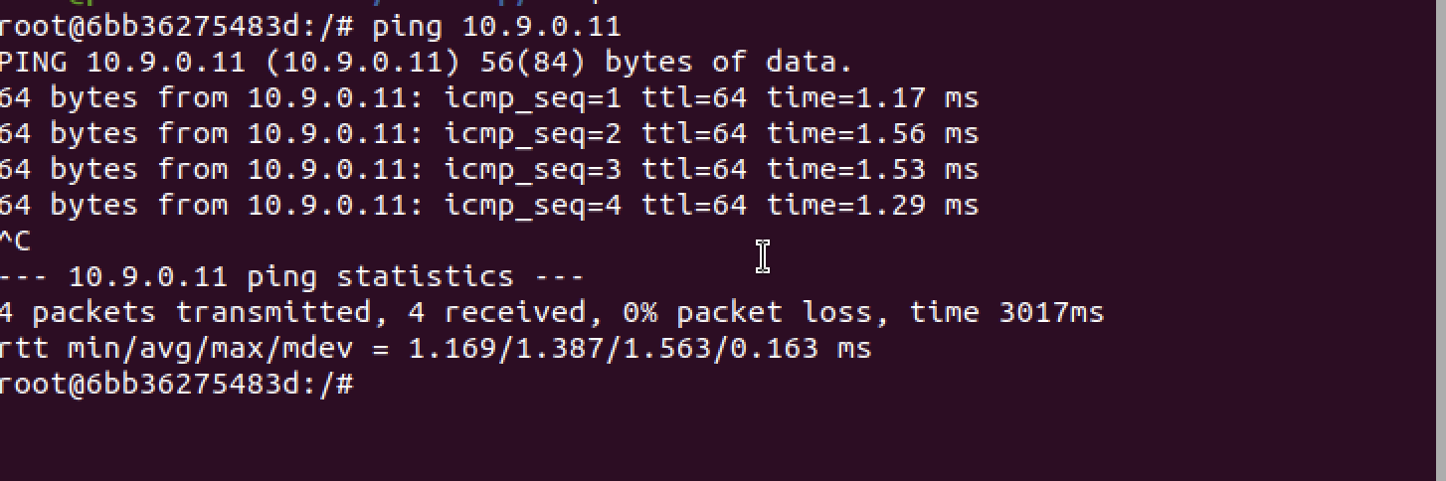

We can see that Host U can communicate to VPN server.

* VPN Server can communicate with Host V.

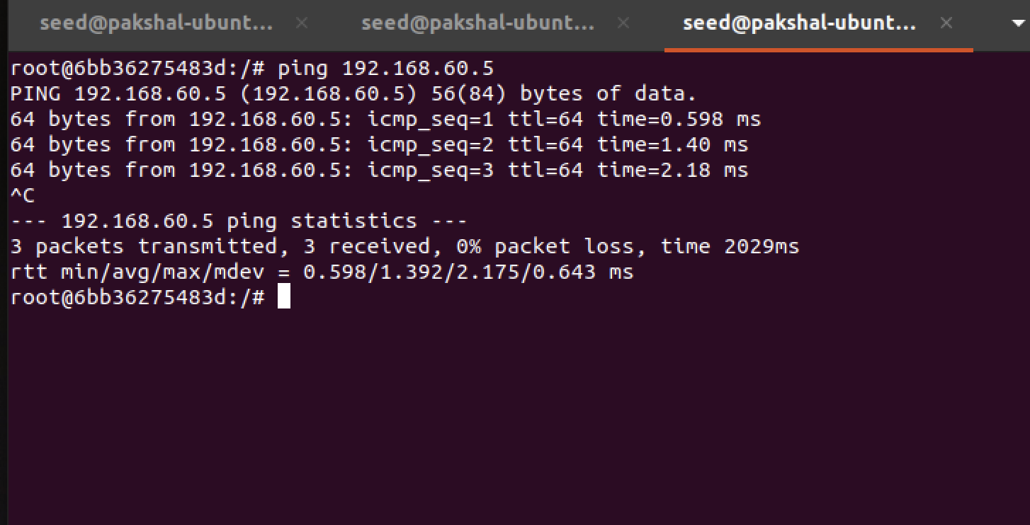

We docksh into the VPN Server in a new terminal instance and ping Host V (192.168.60.5)

* Host U should not be able to communicate with Host V.

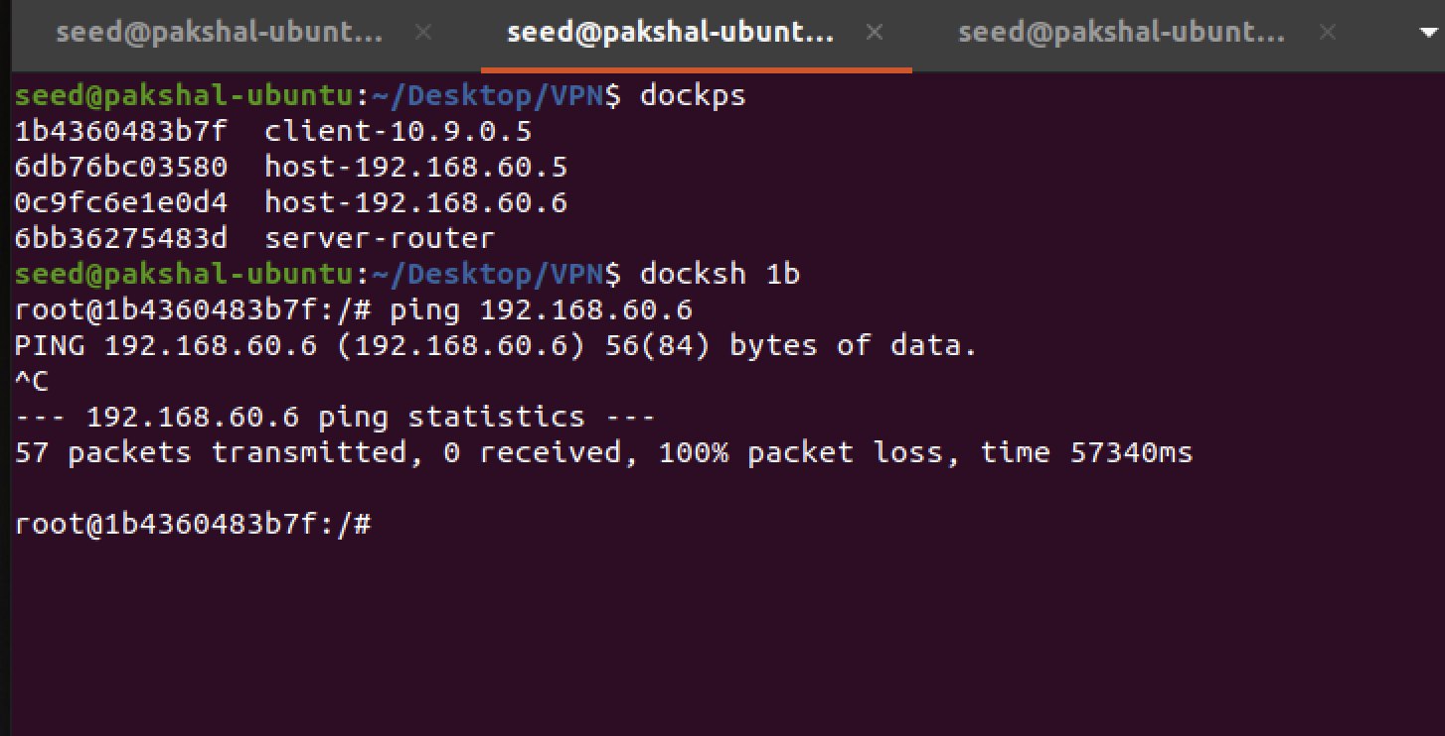

We can see that Host U is not able to communicate with Host V.

* Run tcpdump on the router, and sniff the traffic on each of the network. Show that you can capture packets.

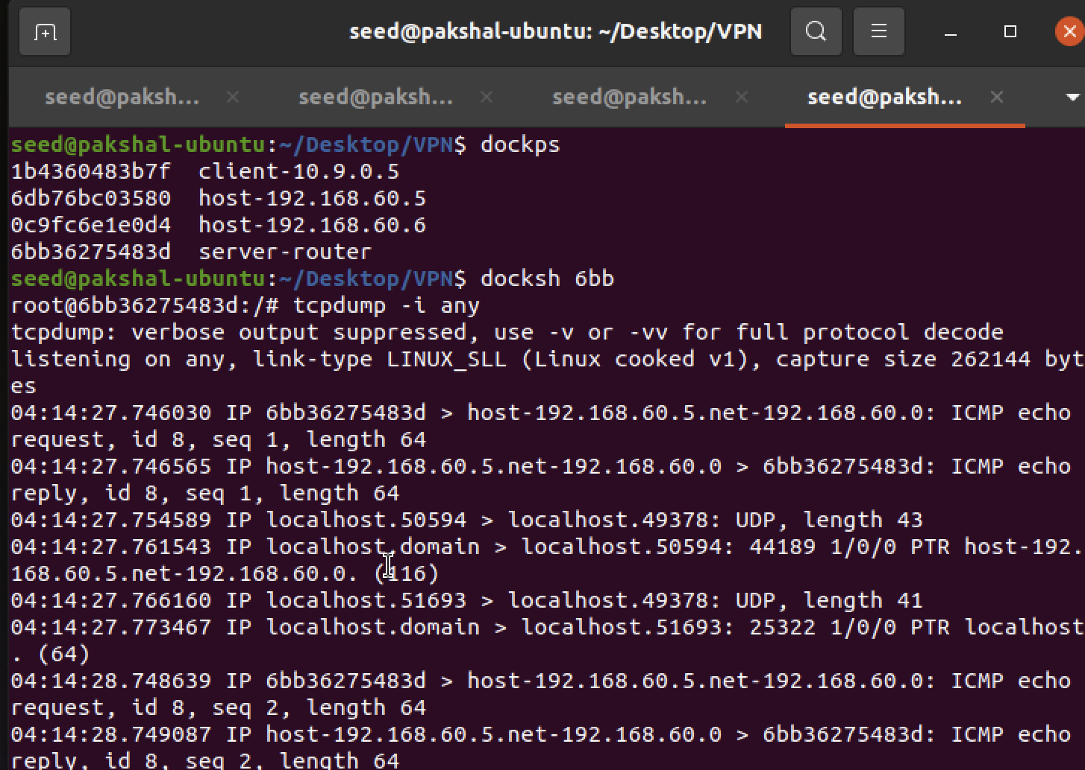

We can see that we are able to capture packets

Task 2

Task 2A

In this sub-task we run tun.py on Host U

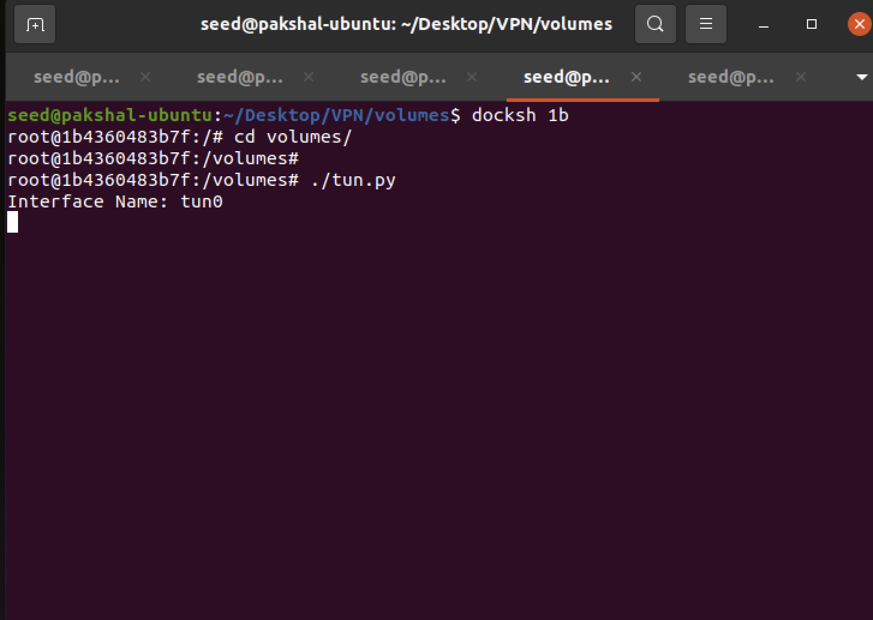

There is a new interface called tun0. This should show up as one of the interfaces after running the command ‘ip address’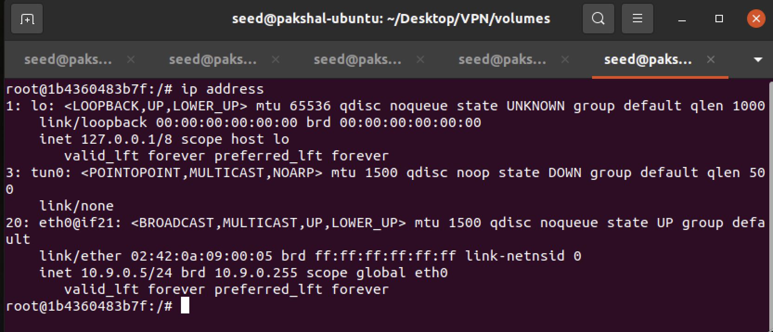

New interface is running called tun0.

The job in this task is to change the tun.py program, so instead of using tun as the prefix of the interface name, we use last name as the prefix.

In my case the first 5 letters of my last name which is ‘bhanp’.

The modified code for tun.py

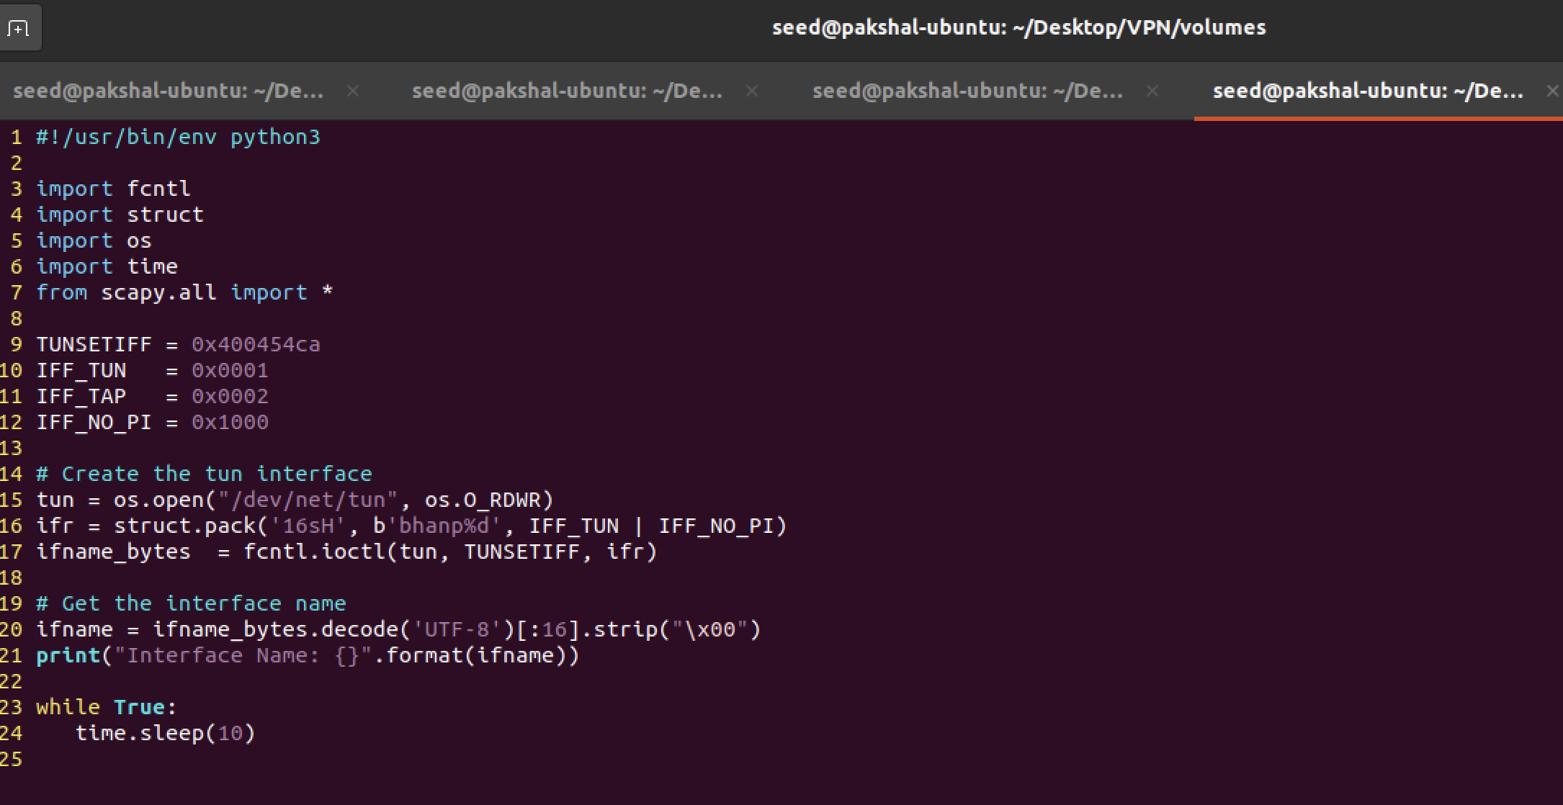

Now we run it again.

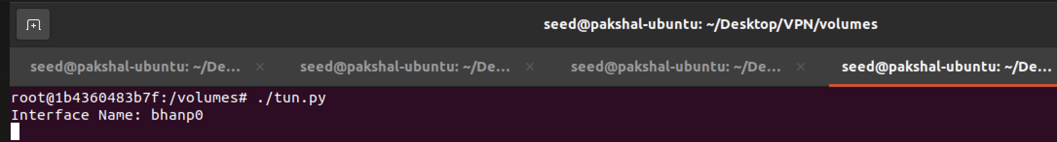

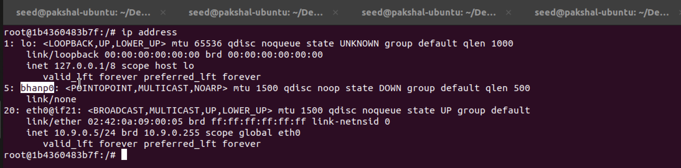

The modified name does show up.

Task 2.B

There are two things that we need to do before the interface can be used.

First, we need to assign an IP address to it.

Second, we need to bring up the interface, because the interface is still in the down state. We can use the following two commands for the configuration in the tun.py

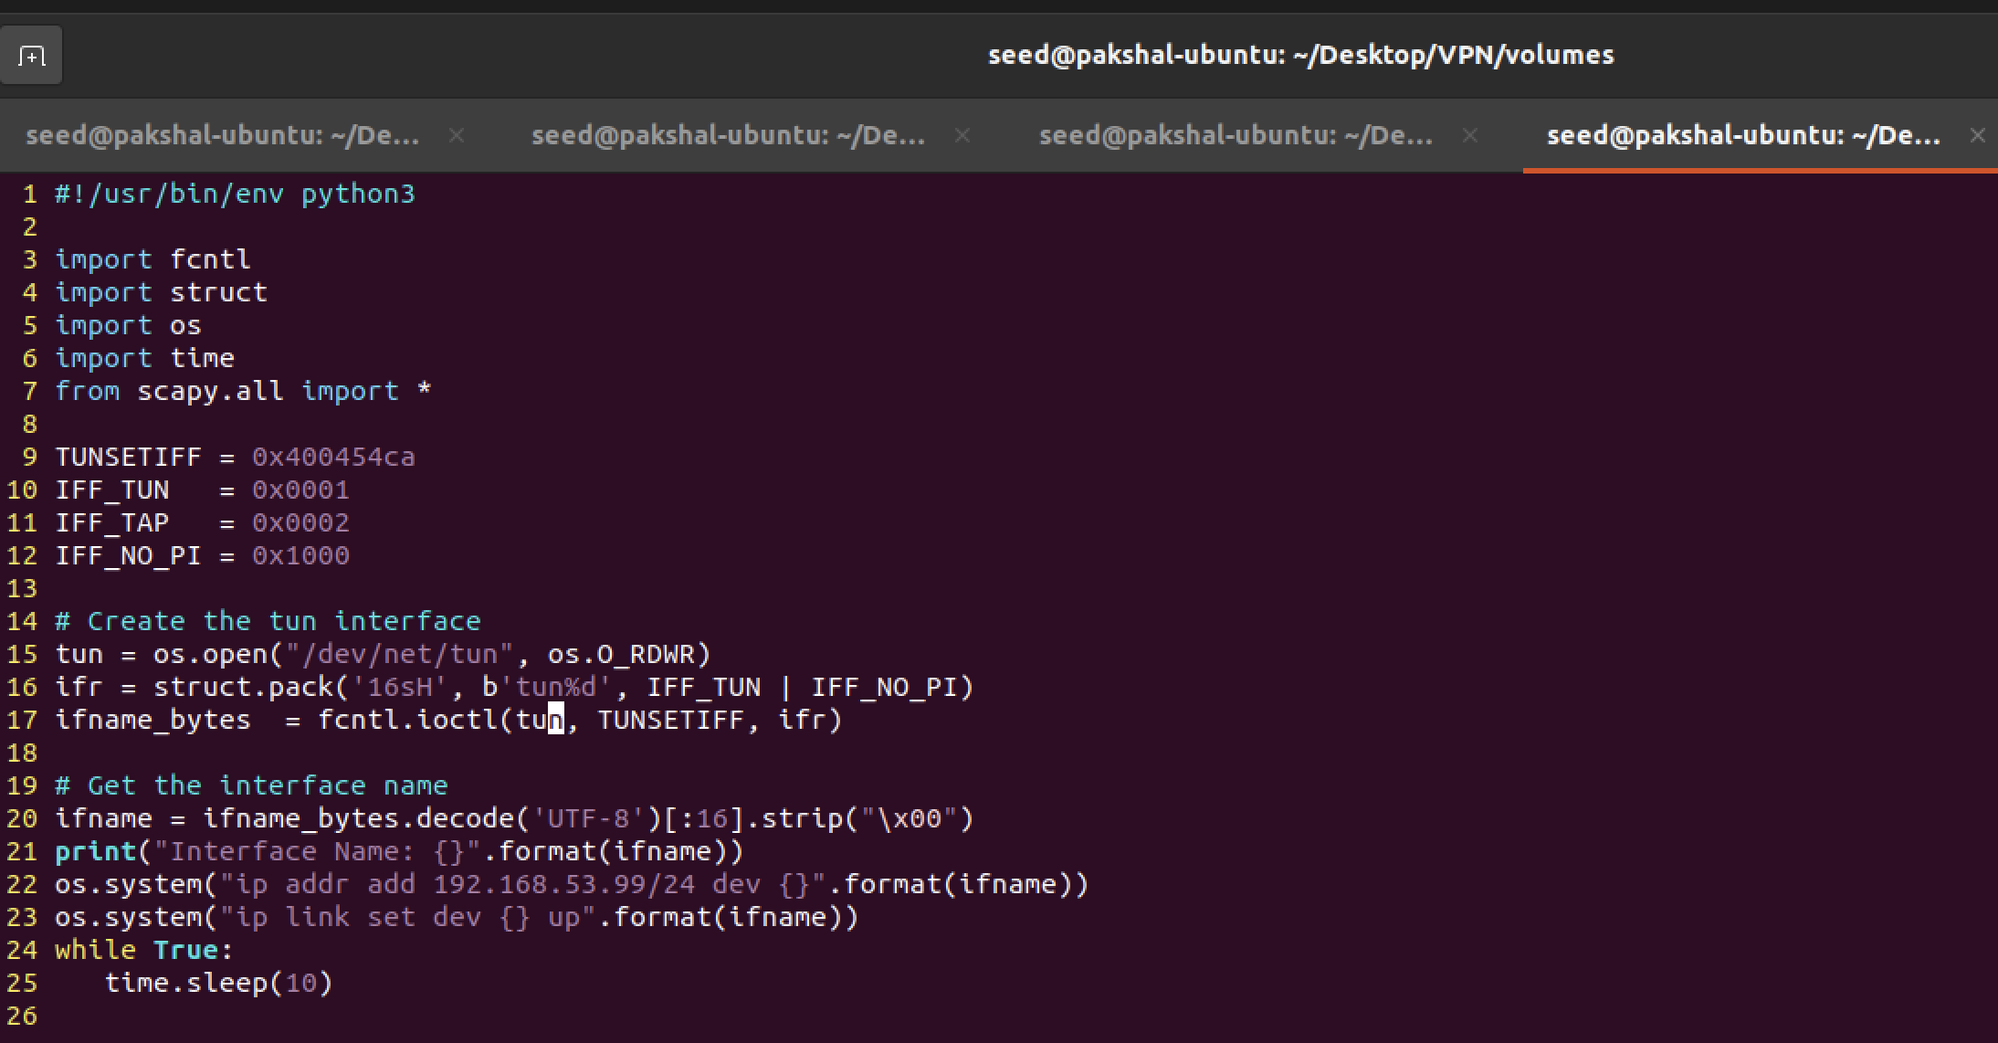

We can see that the interface is assigned the IP address, and the state is now UNKNOWN instead of DOWN.

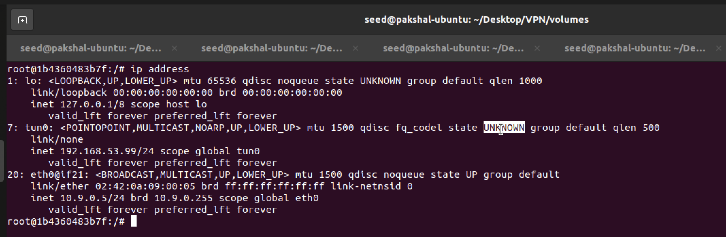

Task 2.C:

We need to read from the TUN interface. We add in the given while loop to replace the one already in the tun.py. Here is the modified code

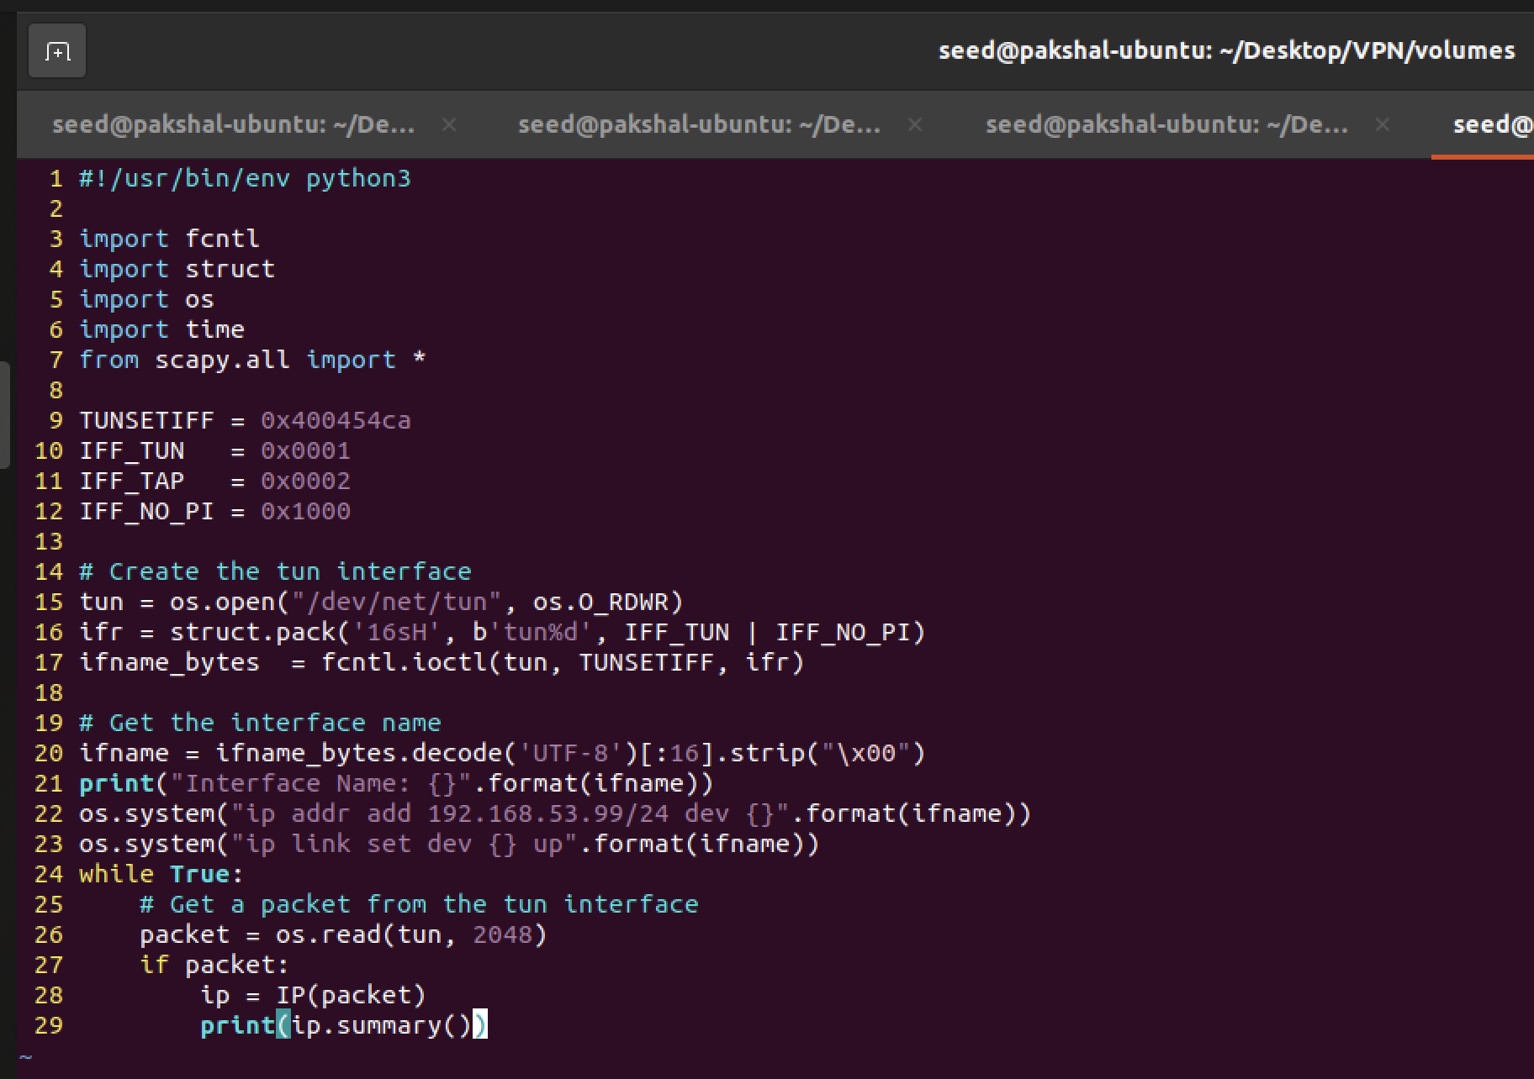

On executing the program

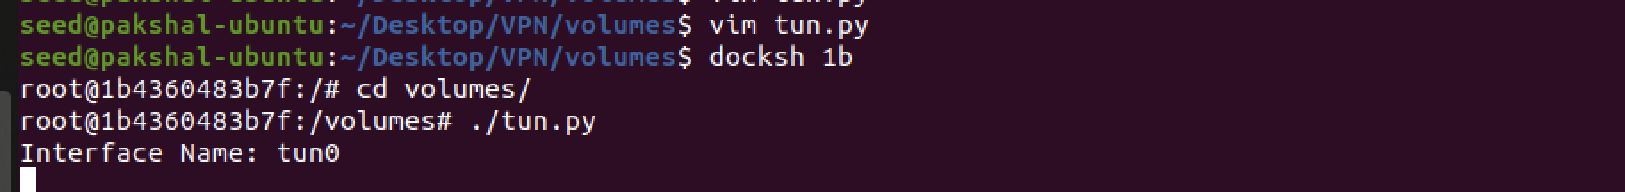

* On Host U, we ping a host in the 192.168.53.0/24 network.

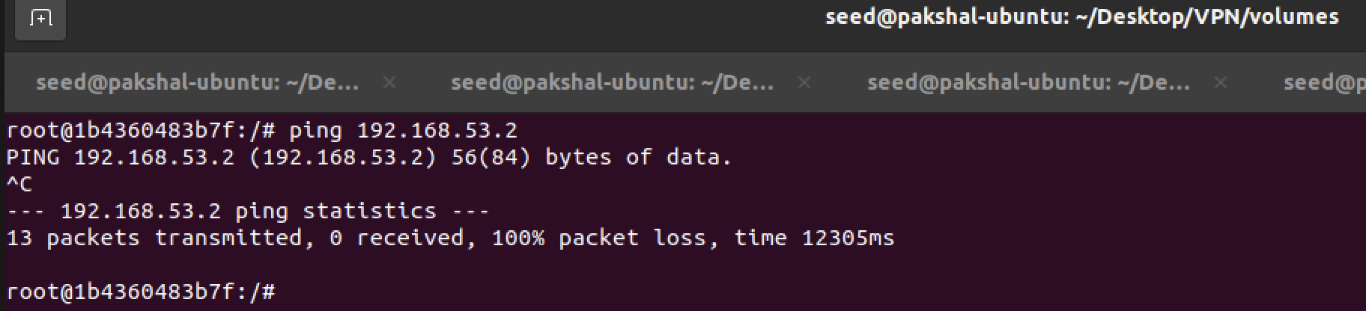

On tun interface we can see the following.

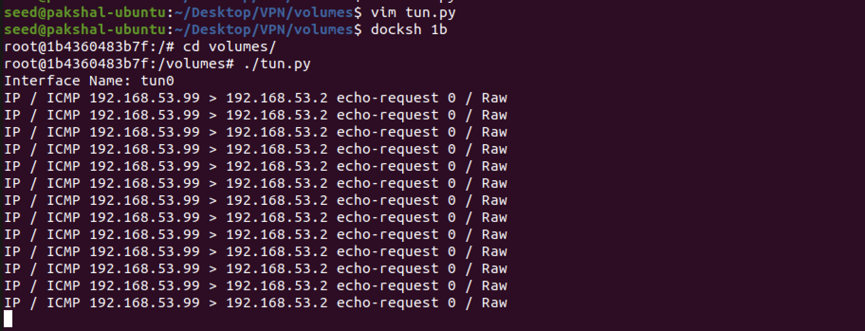

This is happening because TUN interface is setup and assigned 192.168.53.99 IP address. Since we just pinged within the network, the scapy program starts to sniff packets.

* On Host U, we ping a host in the internal network 192.168.60.0/24

We run the tun.py

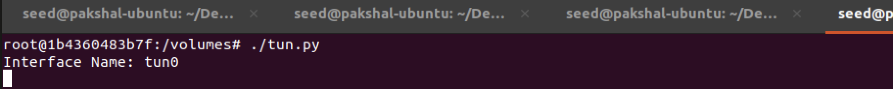

Then we ping a host in the internal network 192.168.60.0/24. I chose to ping 192.168.60.0

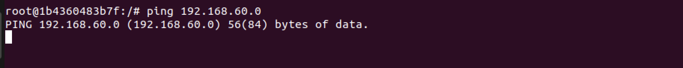



We can see that the interface doesn’t print anything, because this address is not in the network that it is looking for.

**Task 2.D:**

In this task, we need to write to the TUN interface. Since this is a virtual network interface, whatever is written to the interface by the application will appear in the kernel as an IP packet.

After getting a packet from the TUN interface, we construct a new packet based on the received packet and then write the new packet to the TUN interface.

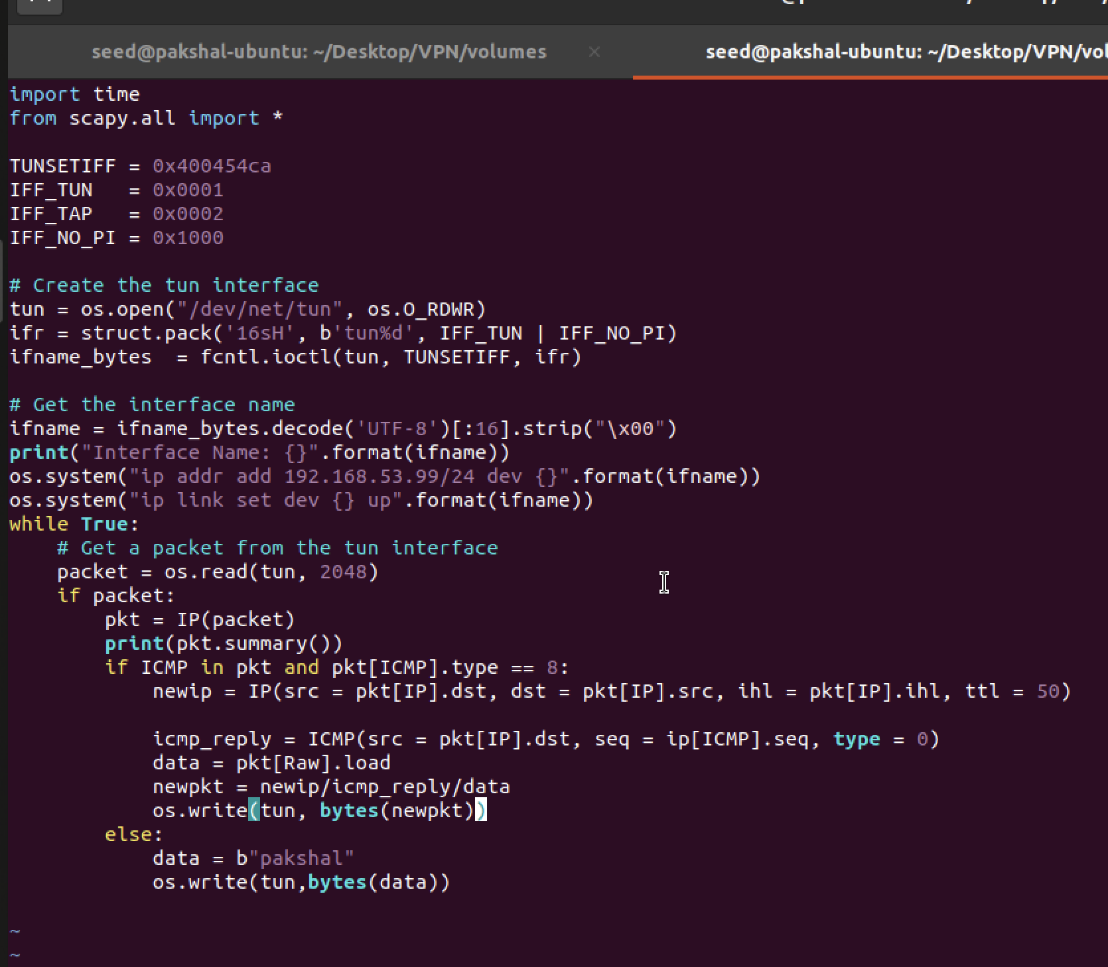

We run tcpdump on the tun0 interface.

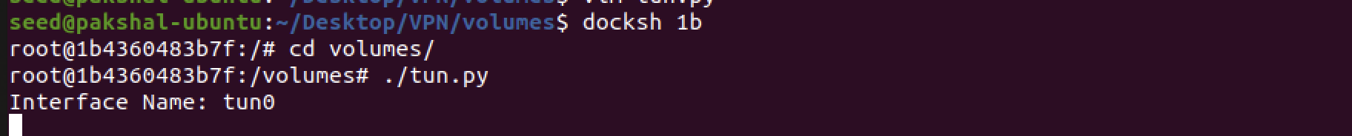

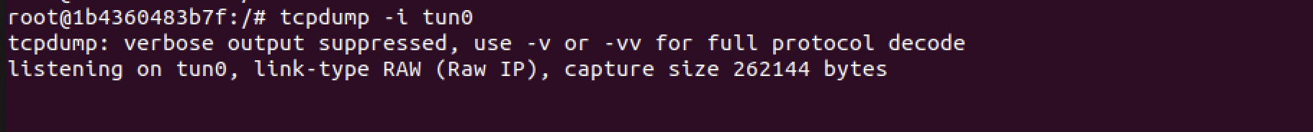

This shows that when an ICMP request is sent from Host U to the network

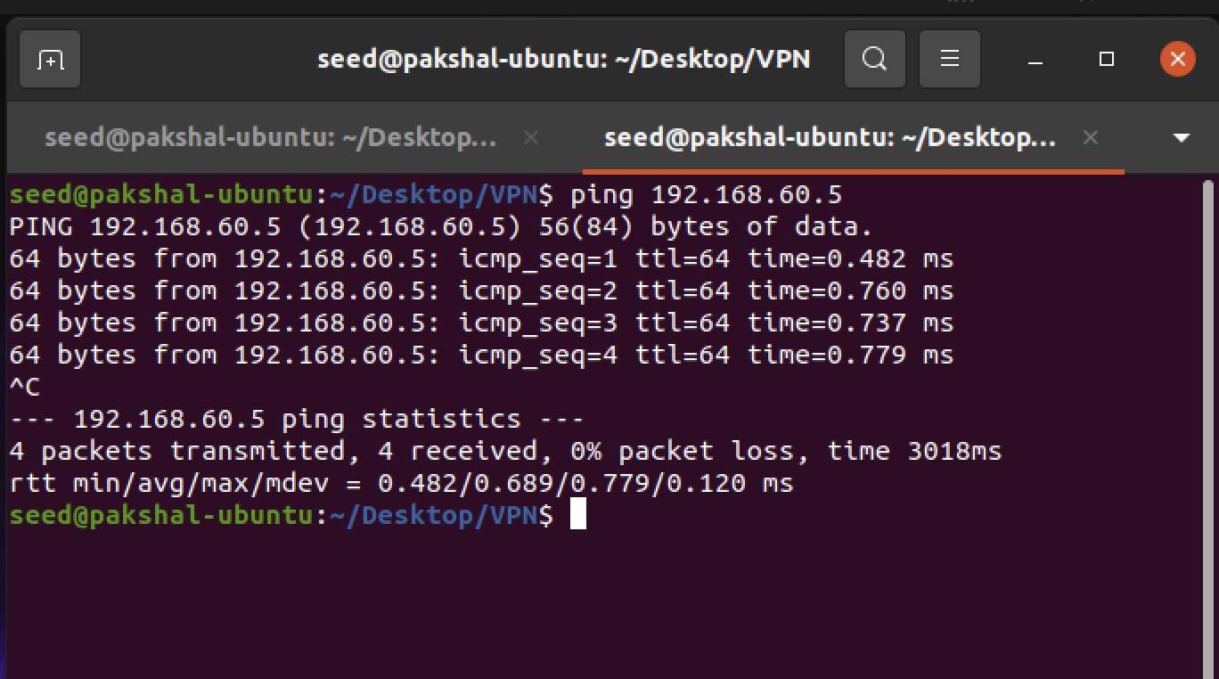

**Task 3: Send the IP Packet to VPN Server Through a Tunnel**

Here we have to setup TUN Server and TUN client.

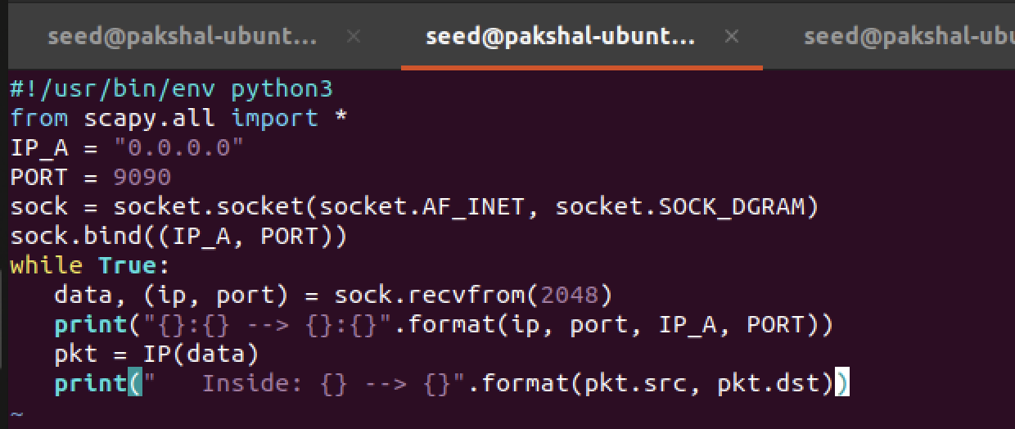

tun_server.py

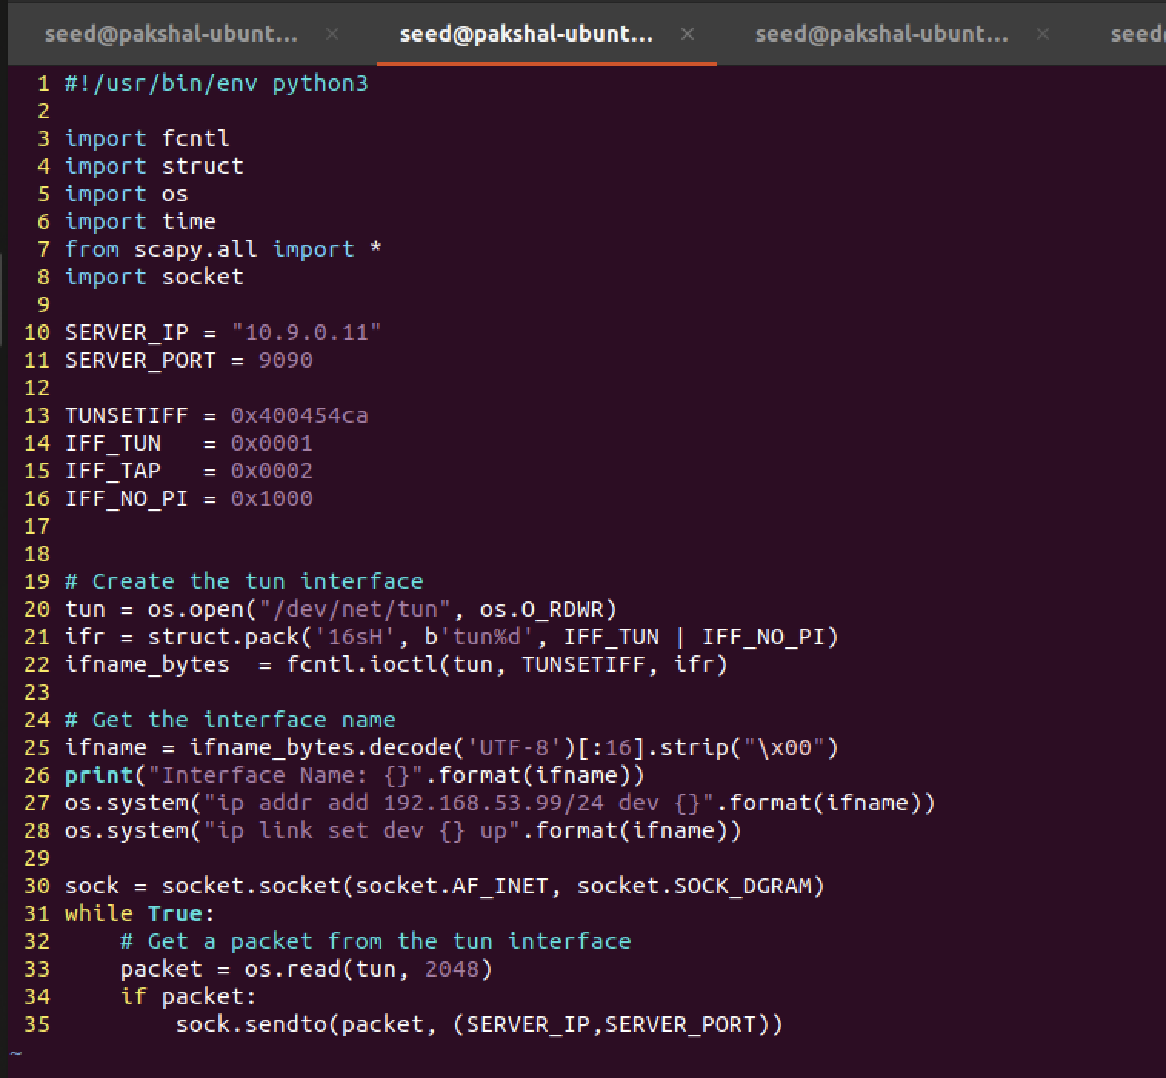

tun_client.py

Now we run these two programs by running the tun server.py program on the VPN Server, and then running tun client.py on Host U.

We run the tun server.py program on the VPN Server, and then running tun client.py on Host U.

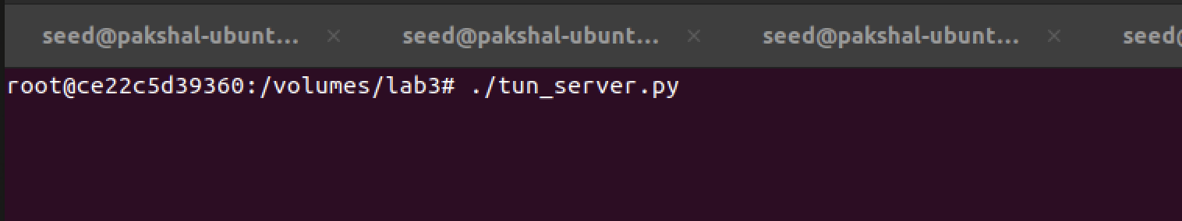

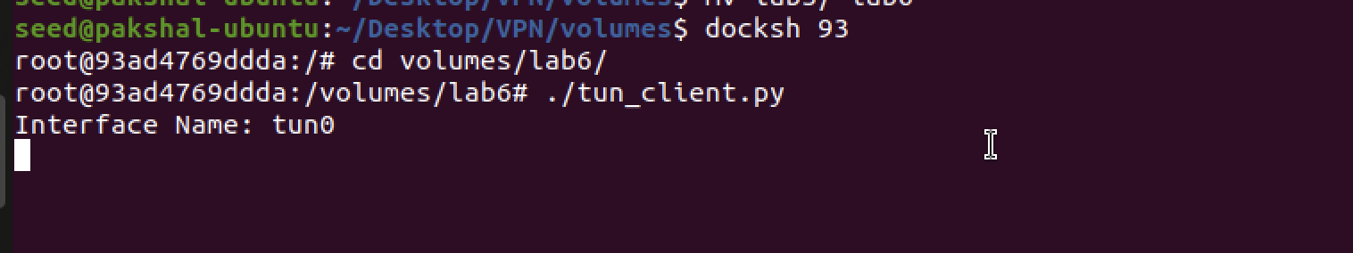

We now ping any host in the internal network of 192.168.53.0/24 from Host U and see what happens. Nothing shows up on the client tun interface but we can see that there is a lot that shows up on the server tun interface.

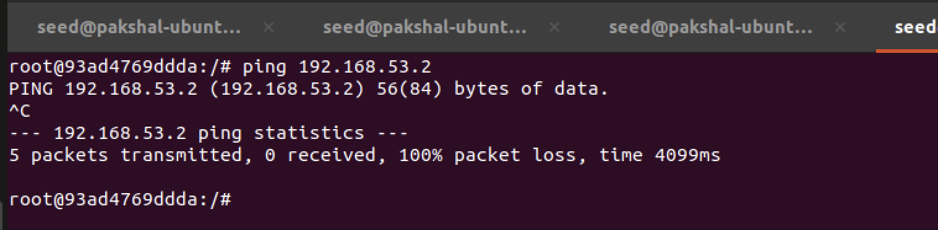

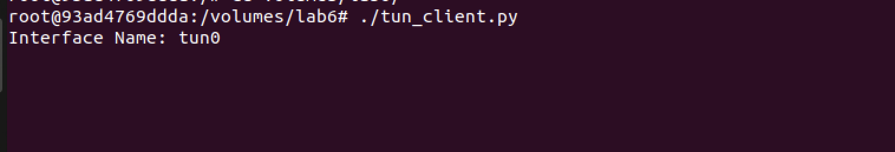

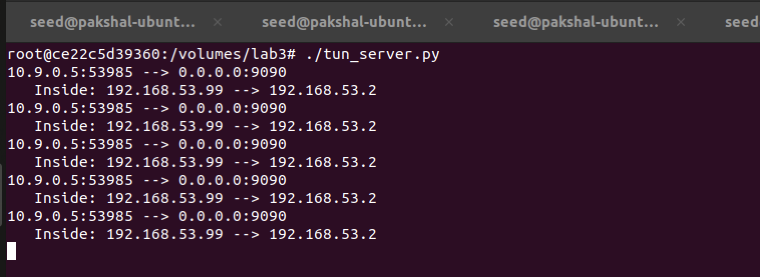

This is because we receive IP packets from host U and print the summary.

Now let us ping Host V, and see whether the ICMP packet is sent to VPN Server through the tunnel.





Nothing shows up on server and client interfaces. We can’t access Host V from U.

We need to add route from route packets from this network to the TUN interface and given to the tun client.

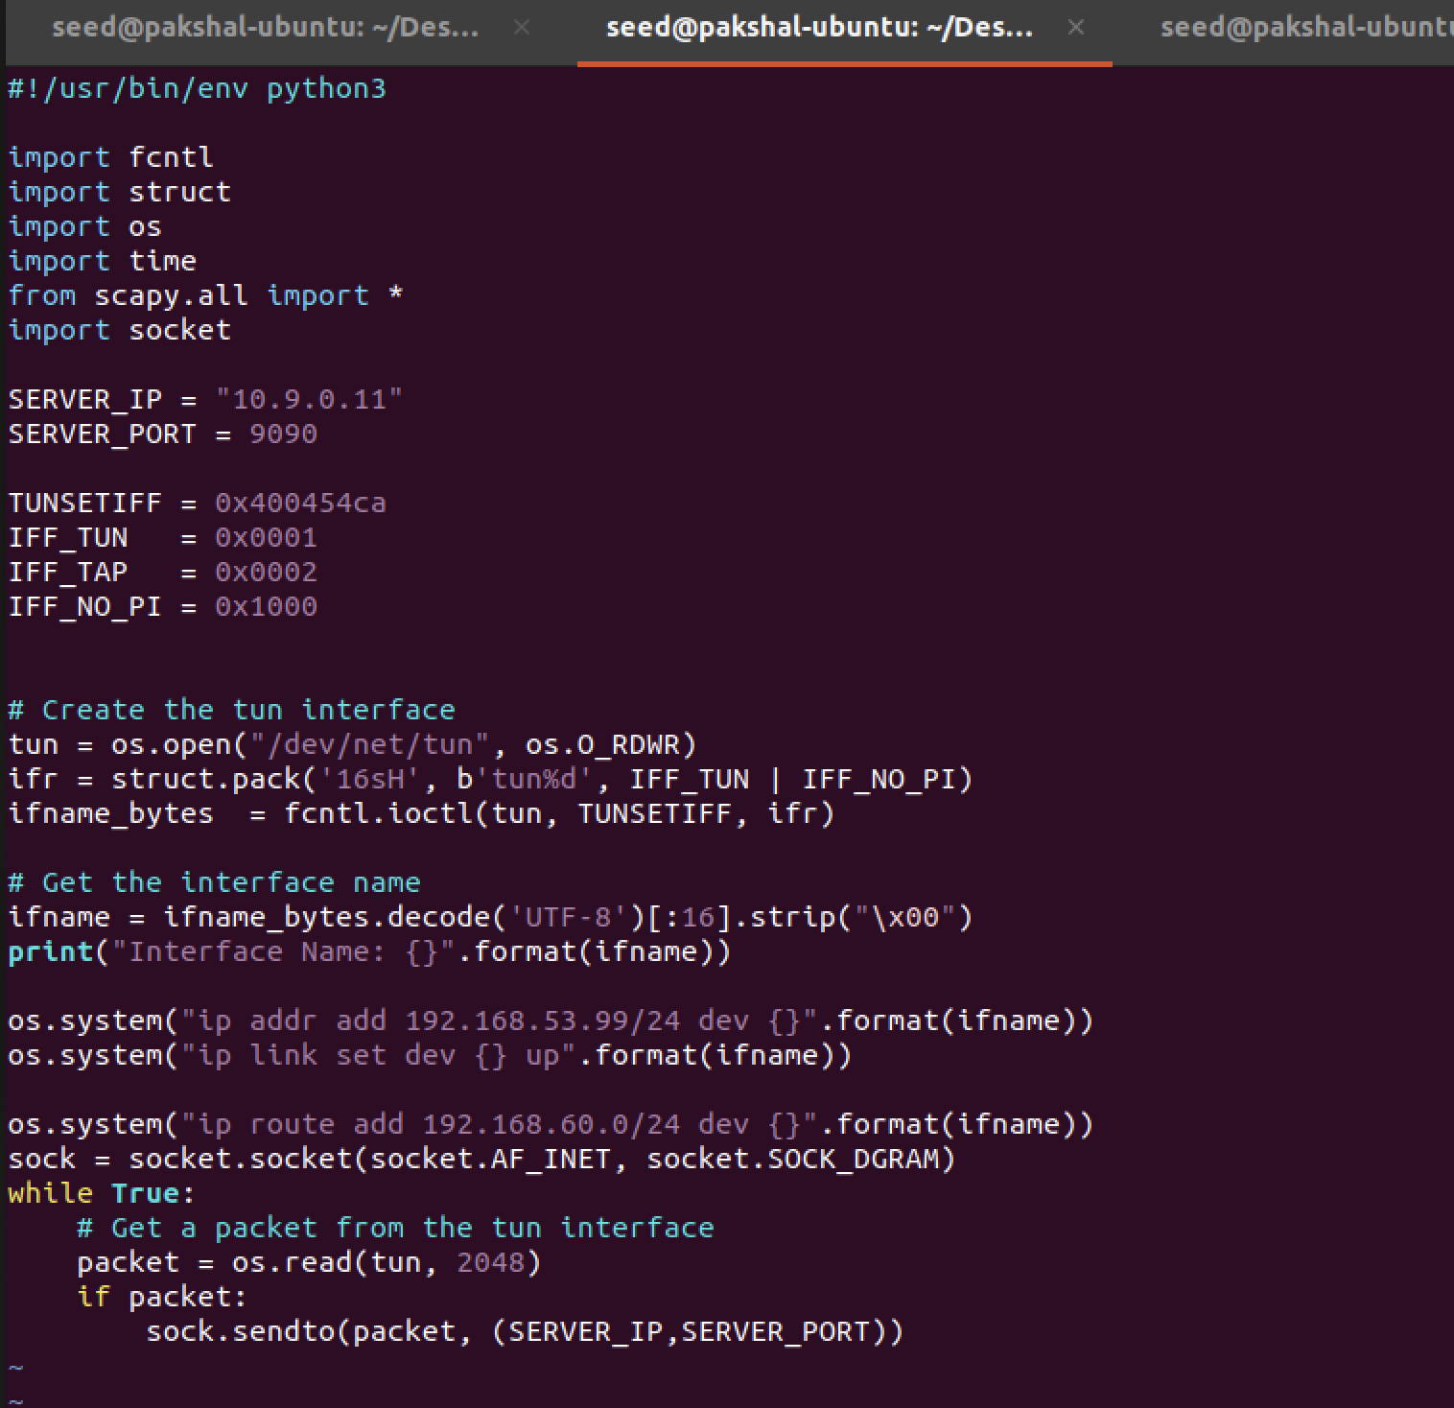

We ping Host V and see tun_server interface

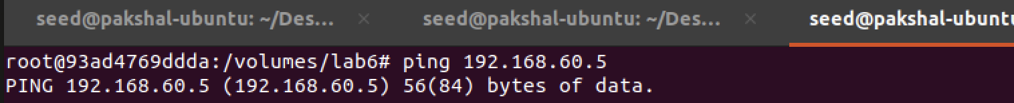

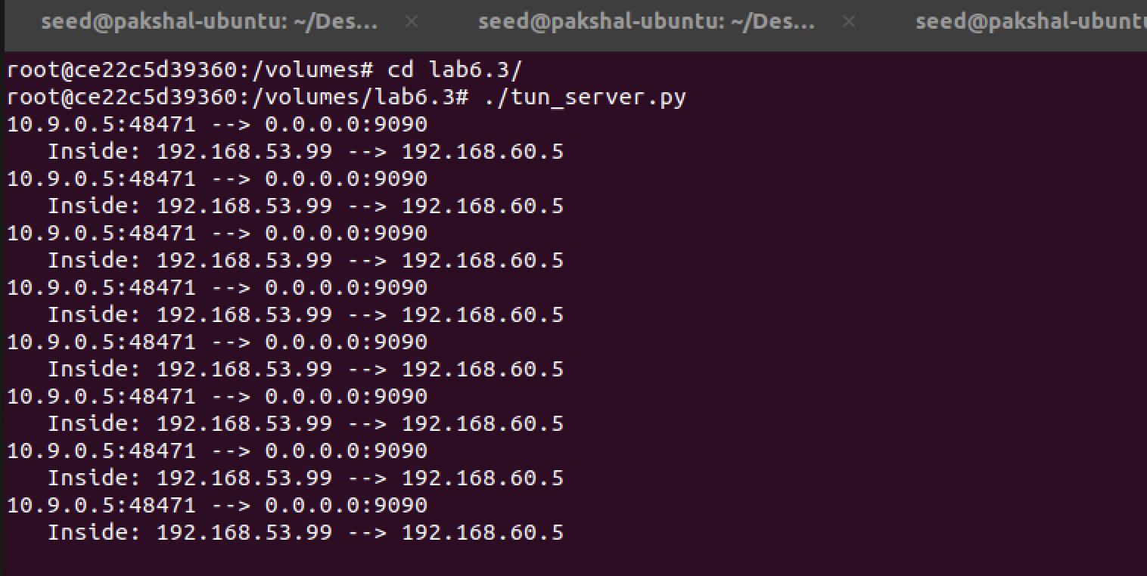

So, when we ping an IP address in the 192.168.60.0/24 network, the ICMP packets are received by tun_server.py through the tunnel.

**Task 4:**

In this sub-task, we need to set up the VPN server. After tun server.py gets a packet from the tunnel, it needs to feed the packet to the kernel, so the kernel can route the packet towards its destination. This needs to be done through a TUN interface, just like what we did in Task 2.

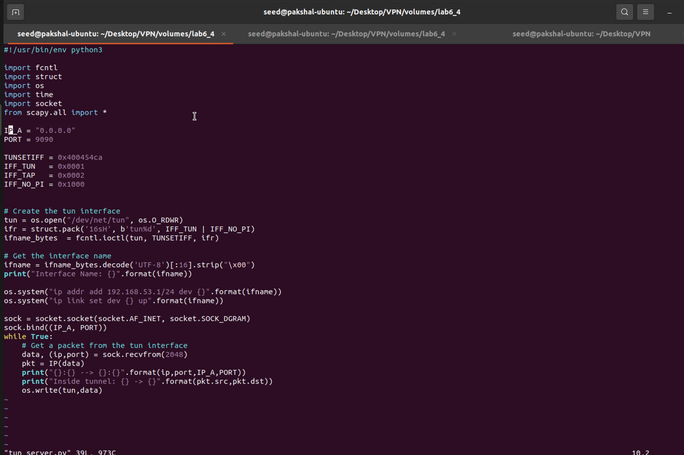

tun_server.py

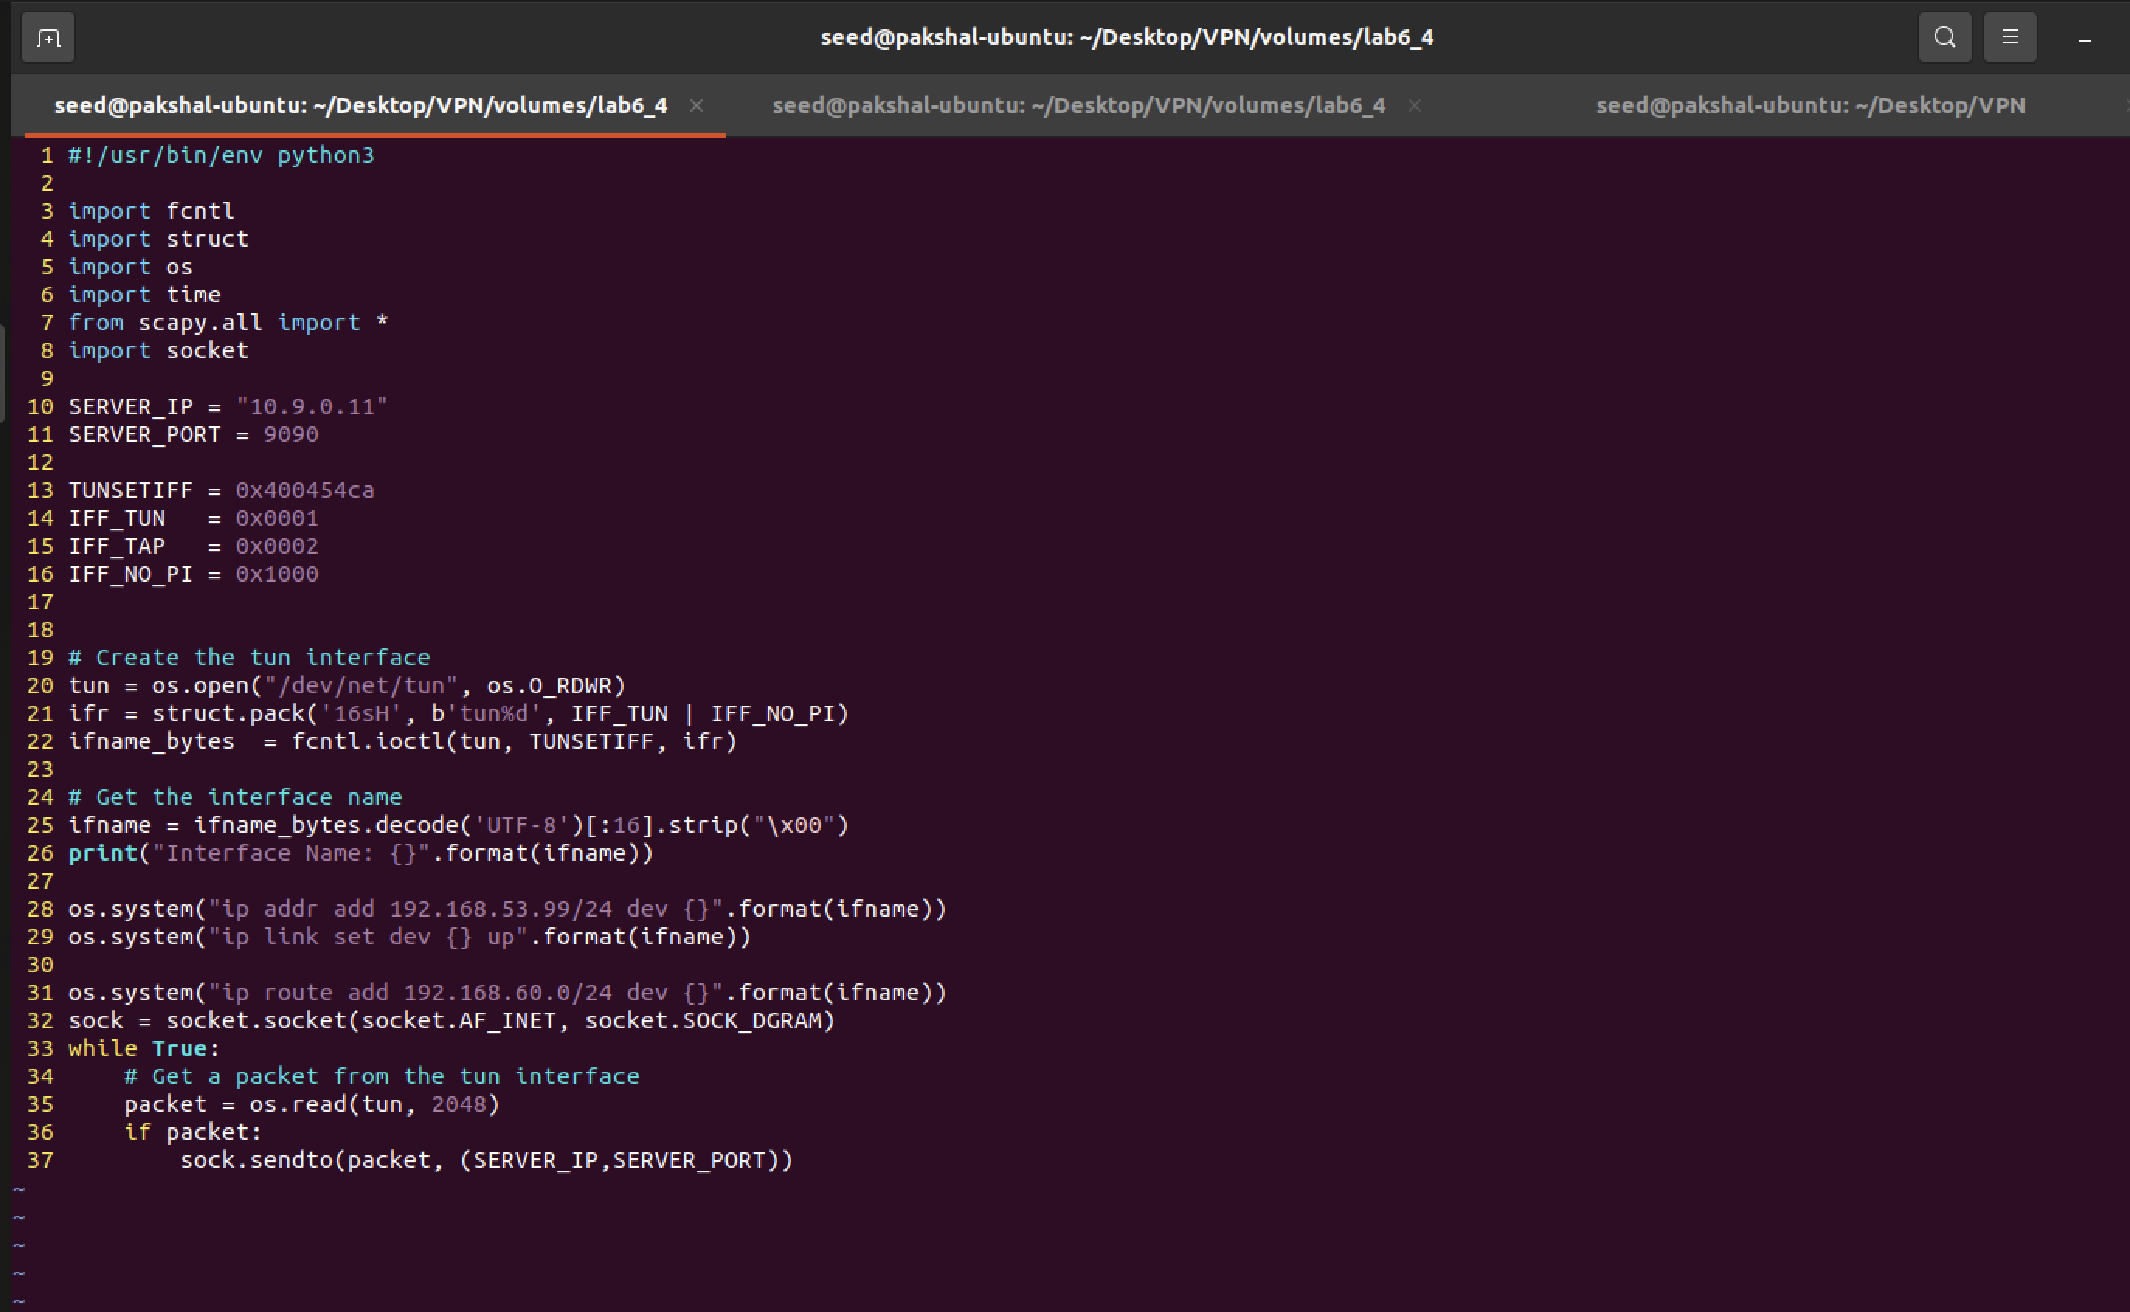

tun_client.py

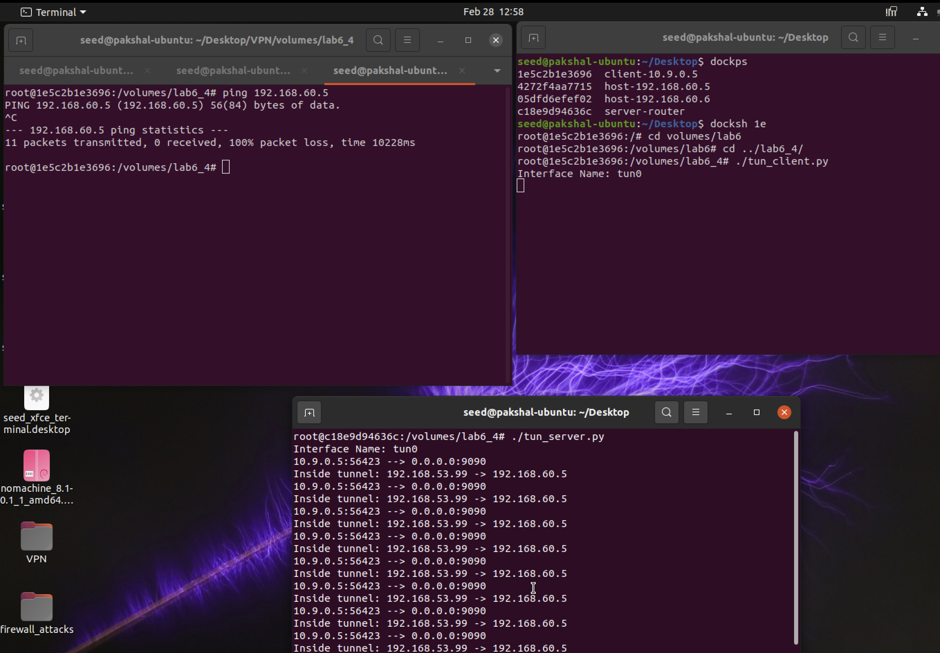

Output

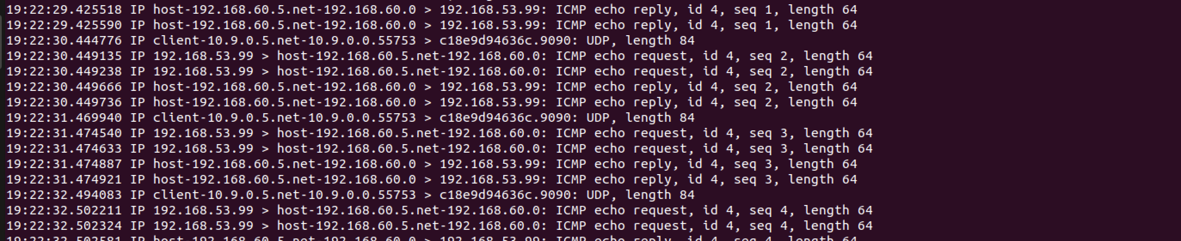

tcpdump output

**Task 5:**

In this task, we need to modify the given code and replace the while loop in both the TUN server and client programs to be able to communicate with Machine V from Machine U, and the VPN tunnel (un-encrypted) should be completed.

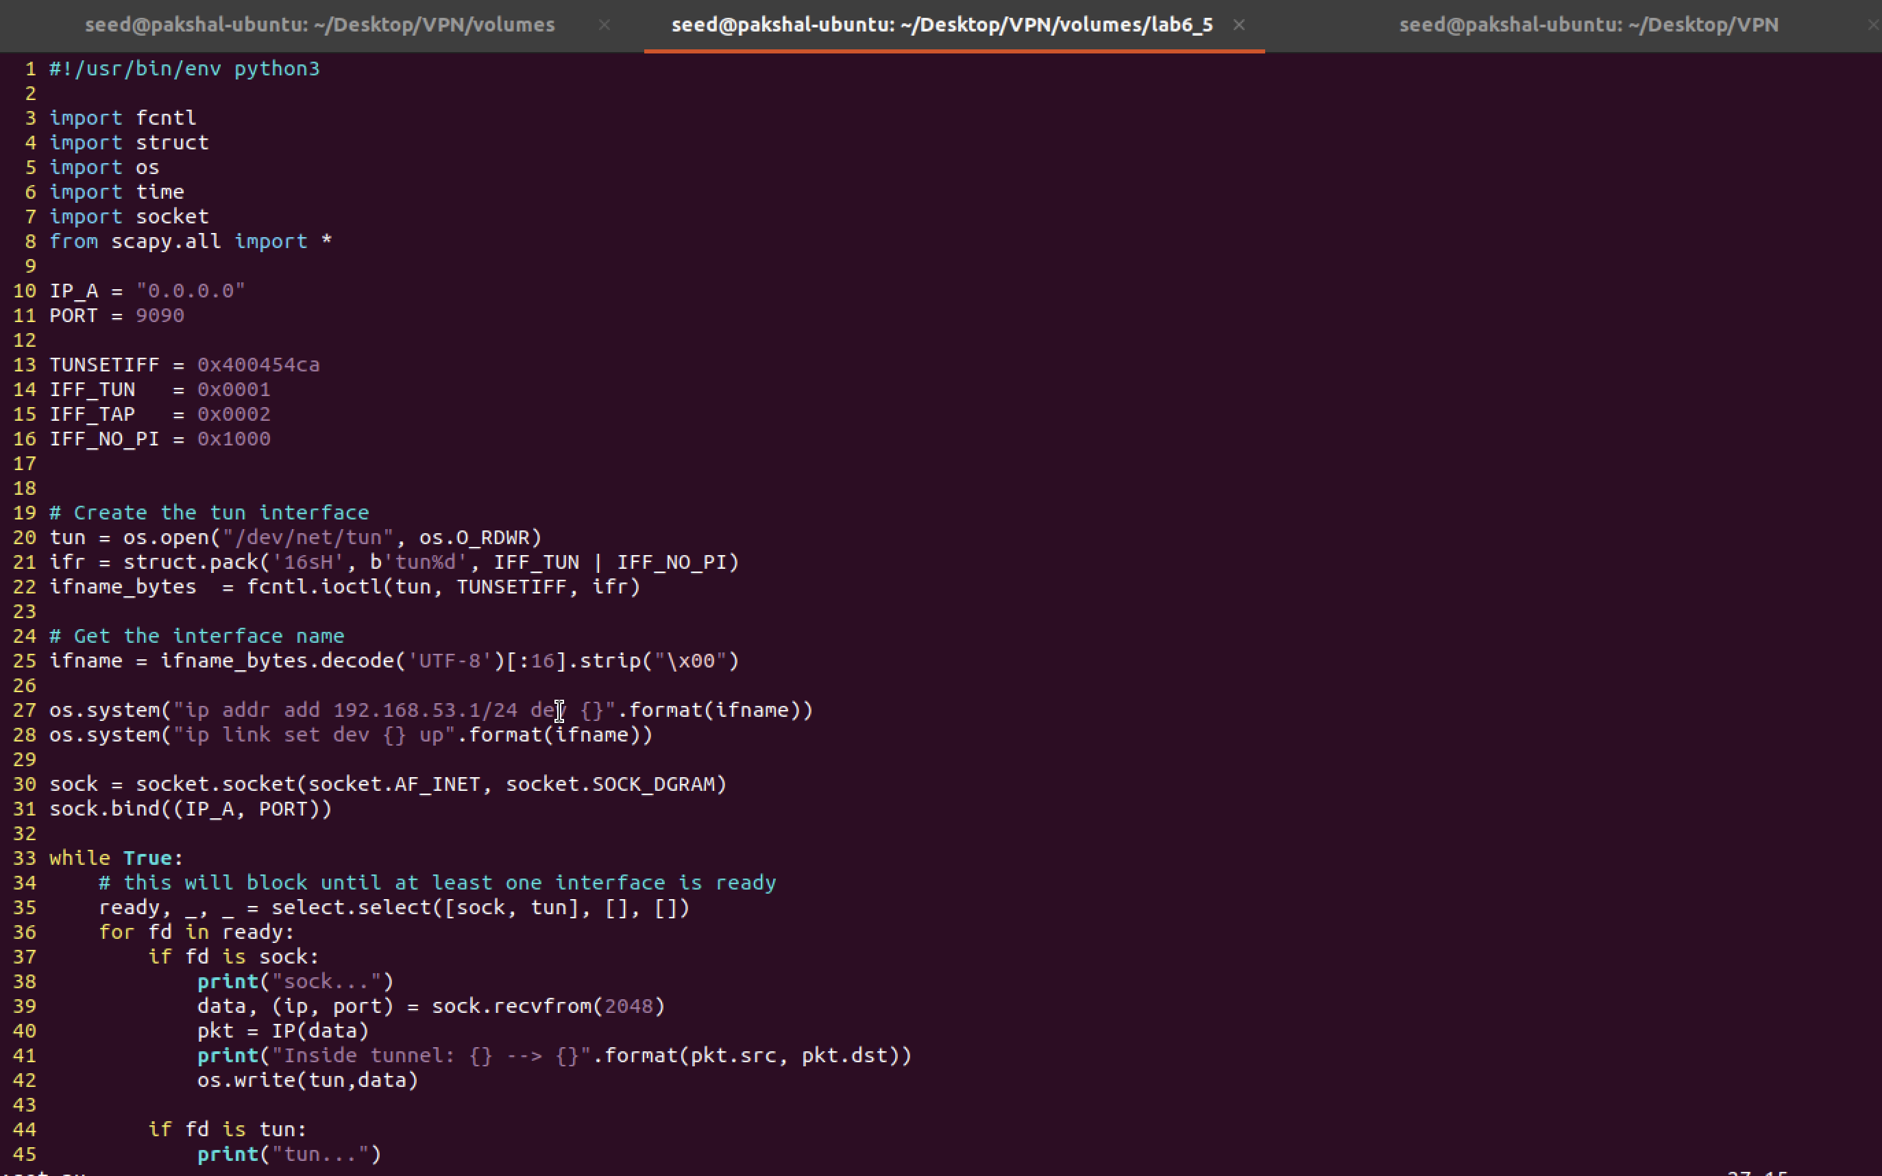

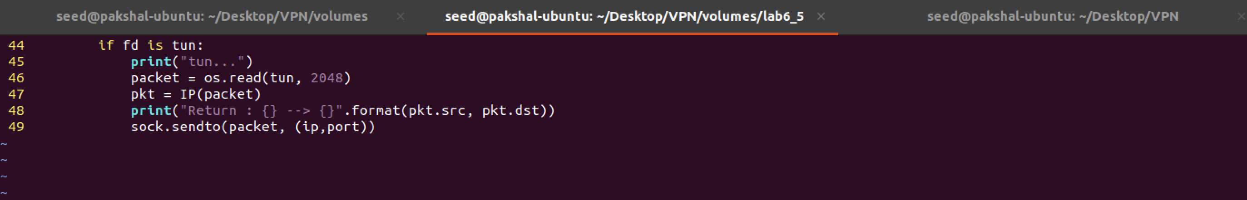

tun_server.py

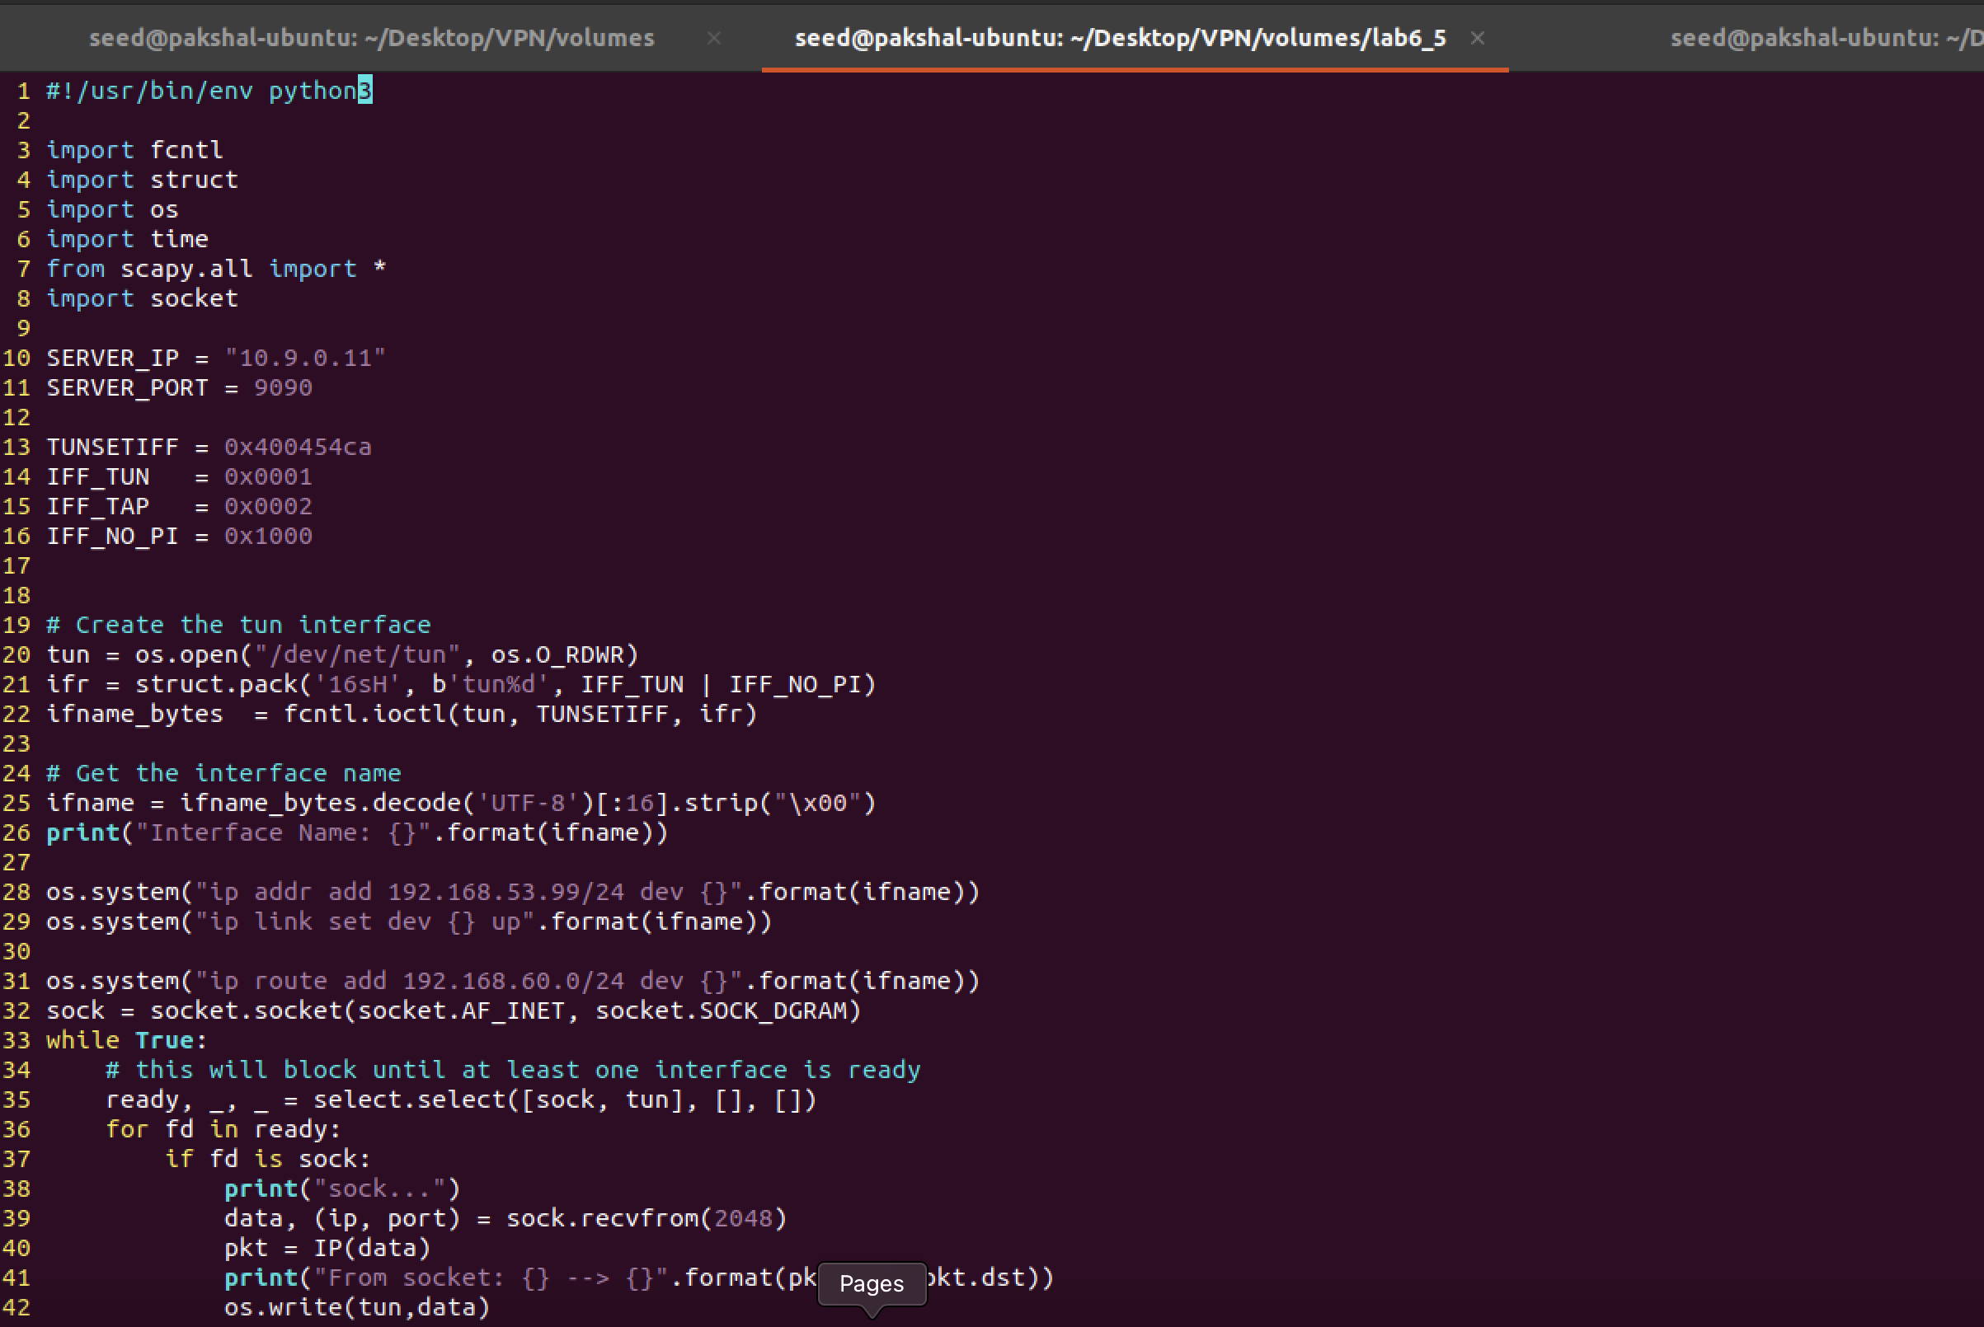

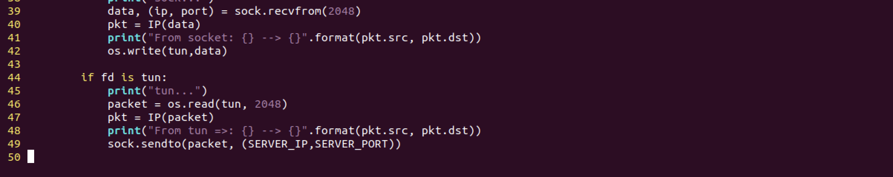

tun_client.py

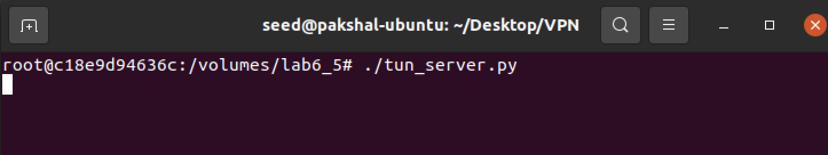

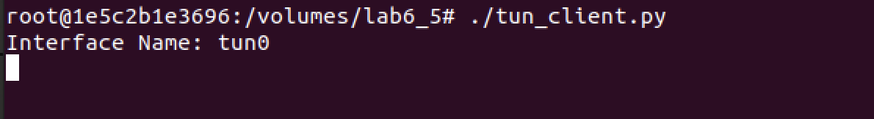

First, we ping Host V from Host U and record the traffic using wireshark.

This is what we observe on the server interface

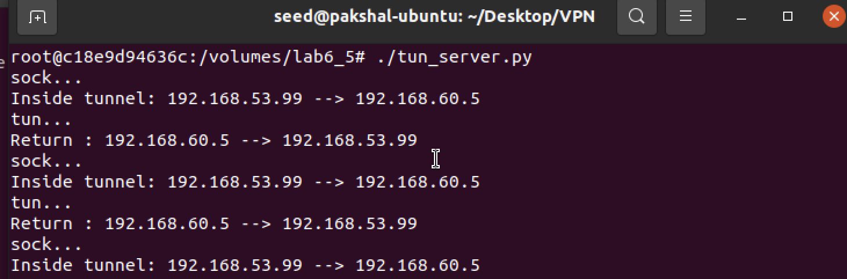

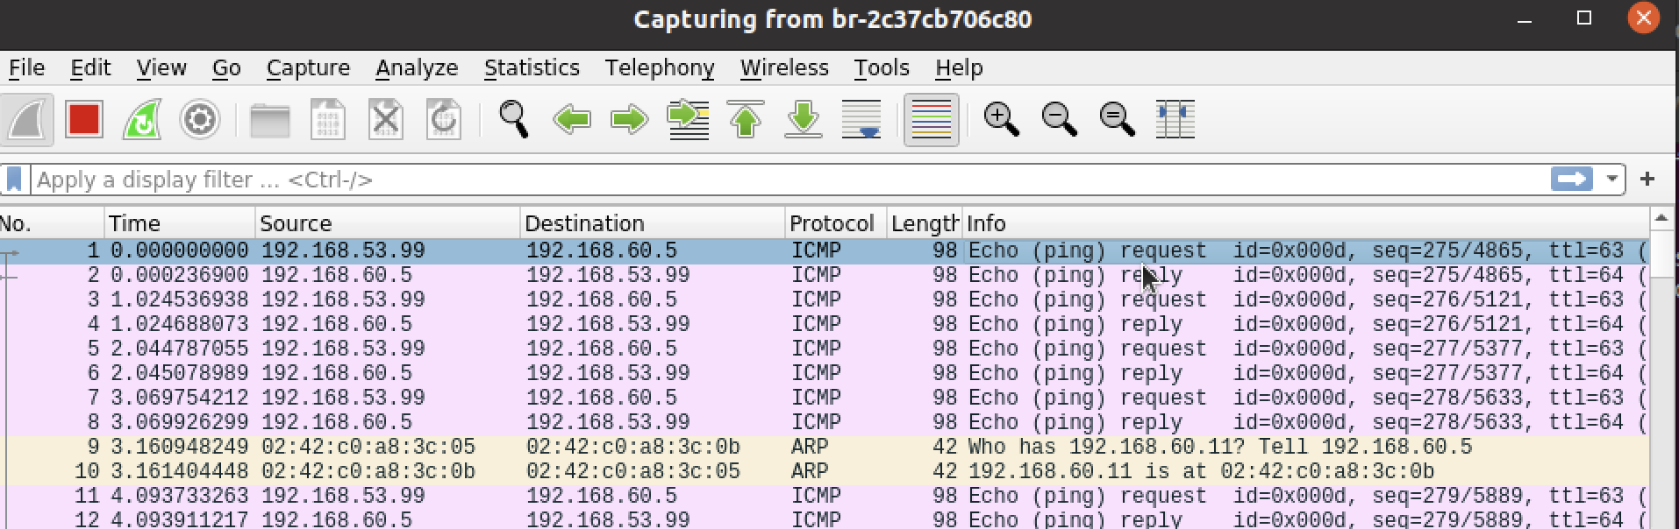

Wireshark capture

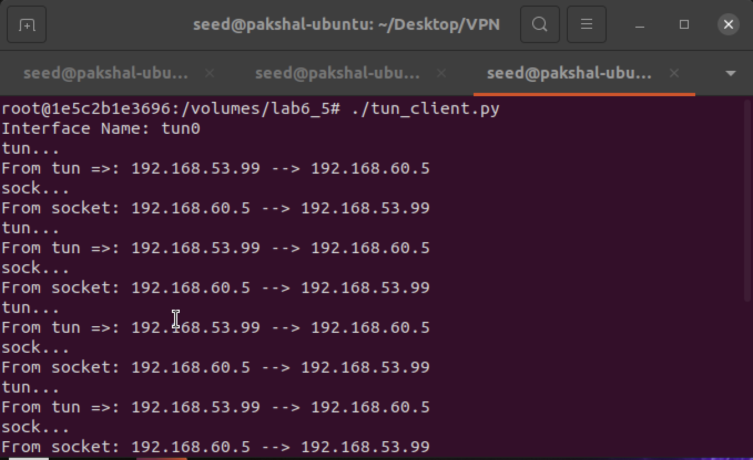

This is what we observe on the tun client interface, wireshark.

We try with telnet.

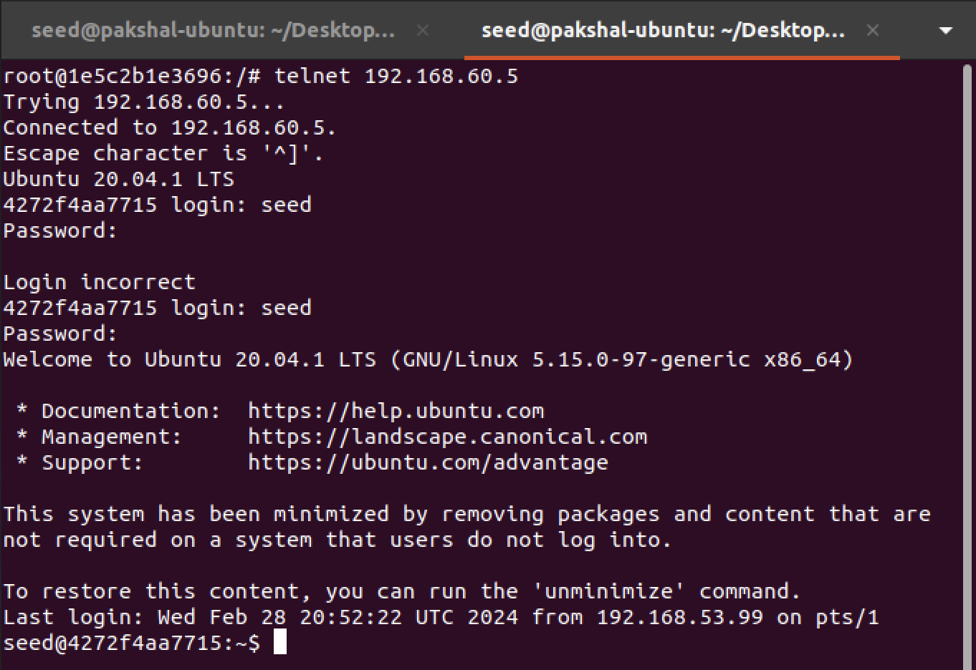

On both the interfaces we observe the following

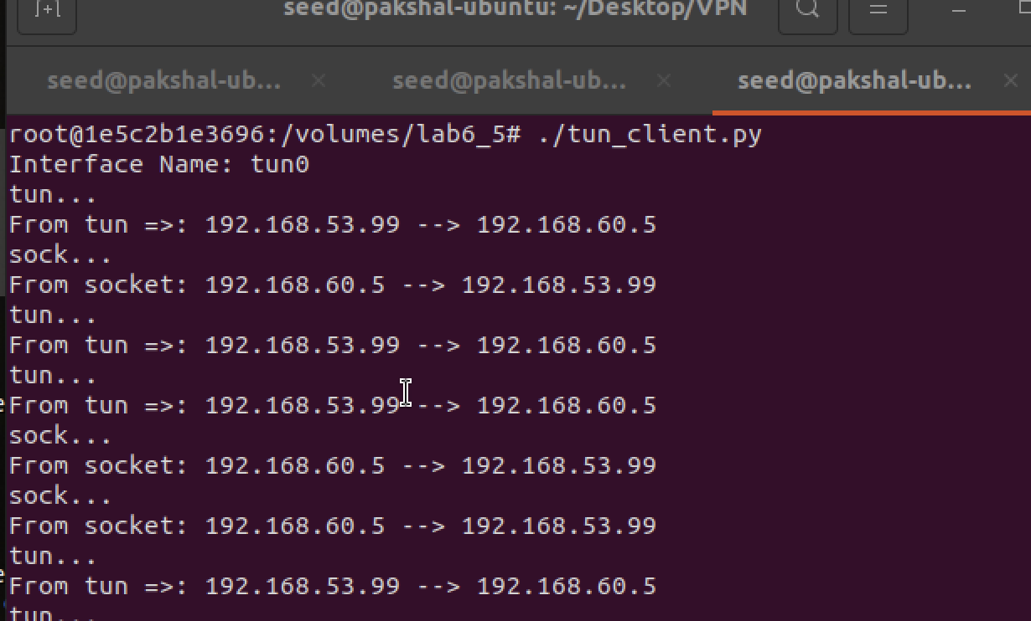

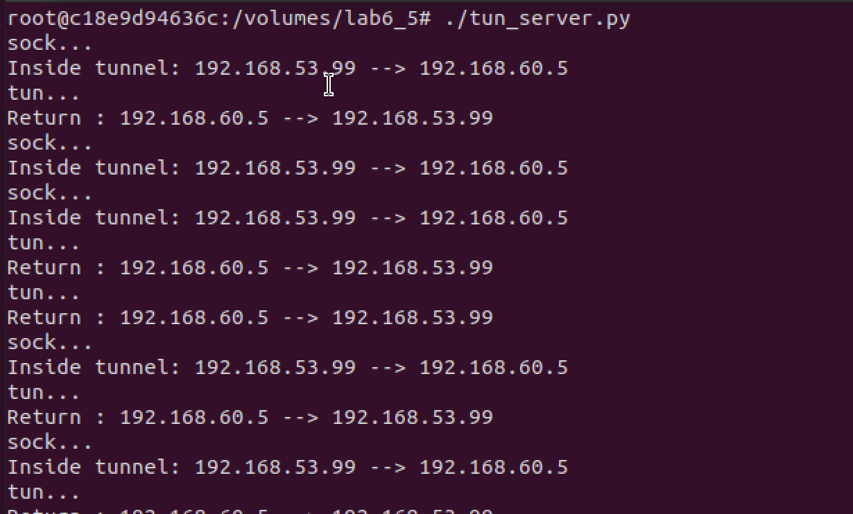

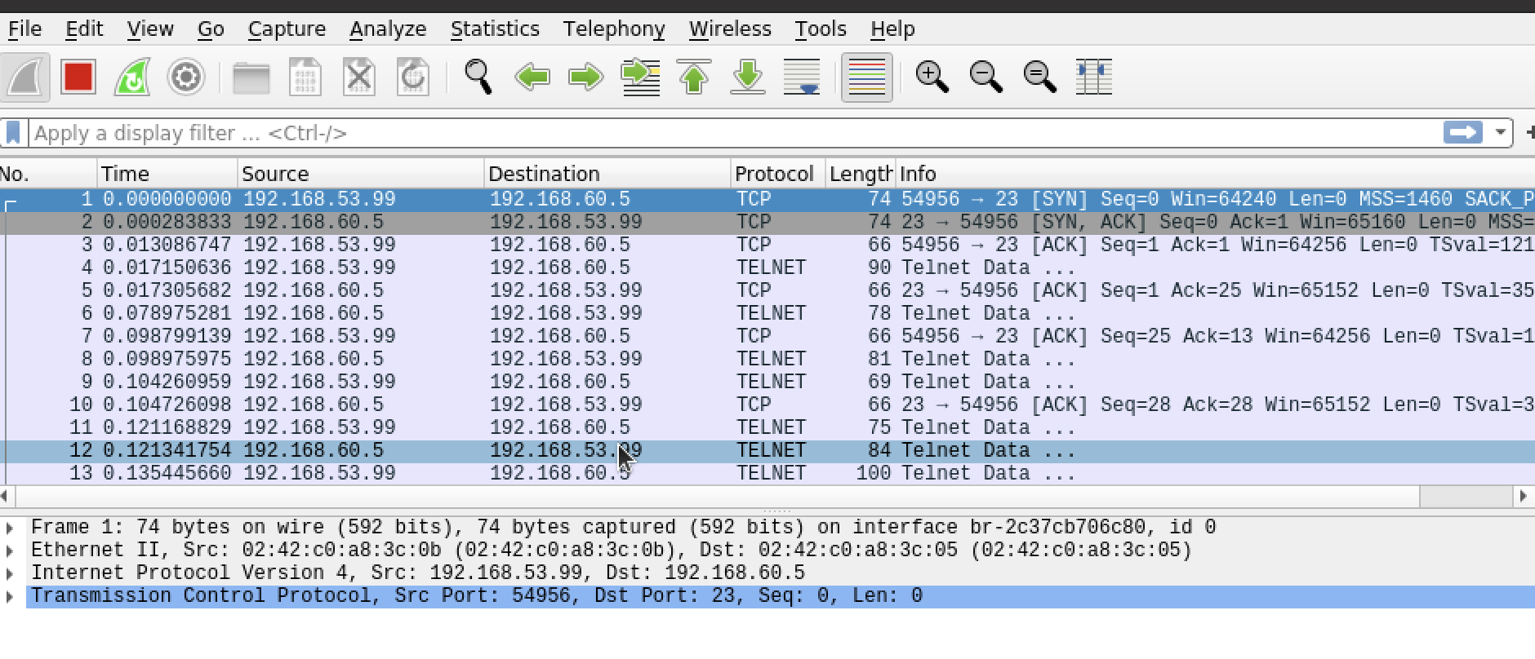

We can see that Host U can also communicate with V via telnet, because we have set up a connection between V and the server, and another between the server and U.

**Task 6:**

In this task, we need to break the tunnel connection established in task 5 and observe what happens with telnet and report the results.

First, we run both the tun server and client programs(same code as task 5) on the server-router and Host U respectively. Now, we telnet to 192.168.60.5 (Host V) from U.

The connection works and is established.

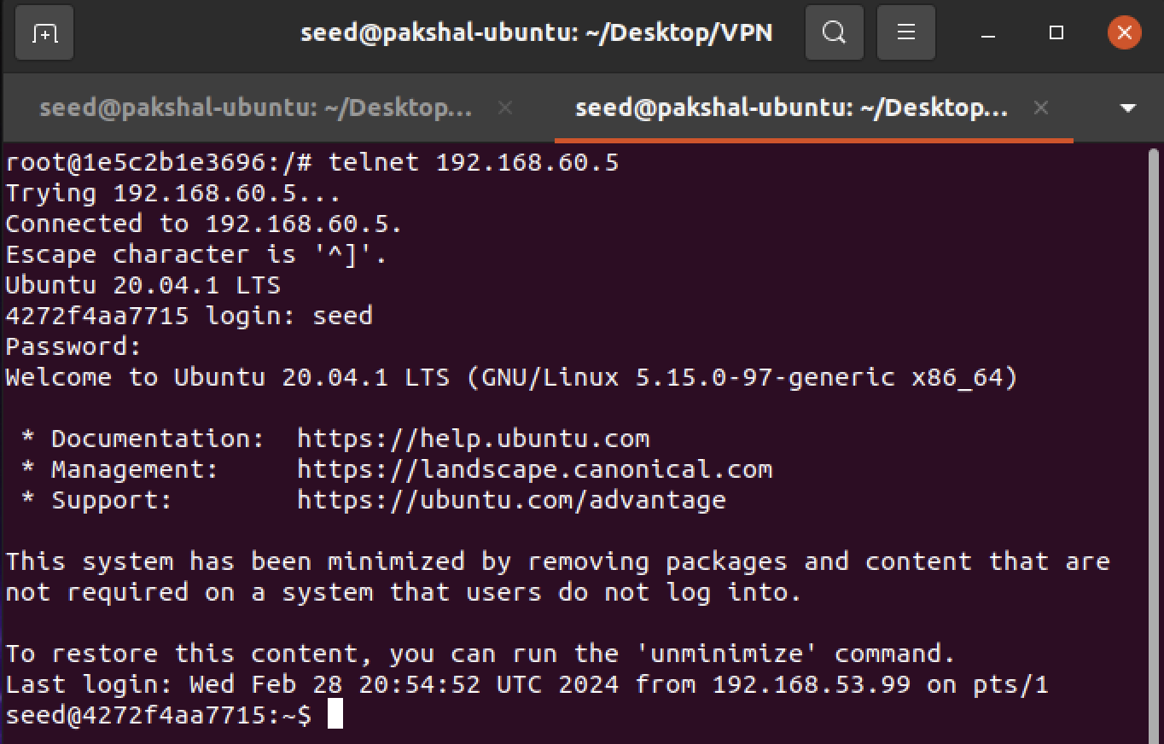

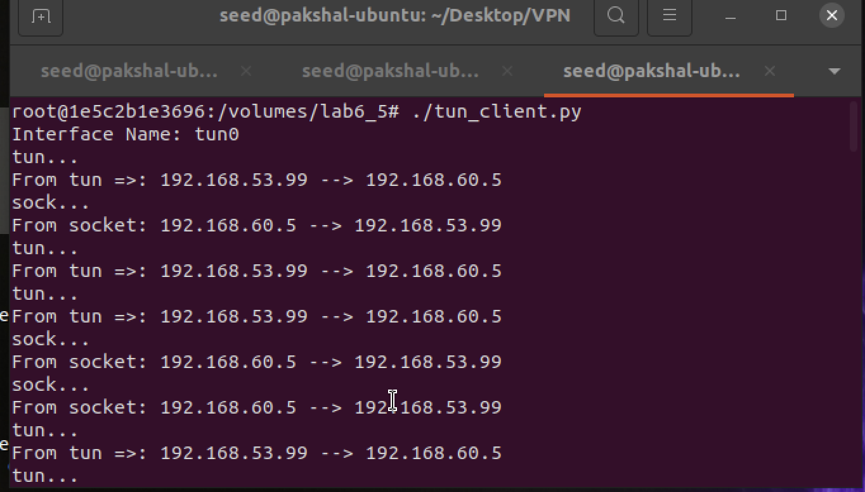

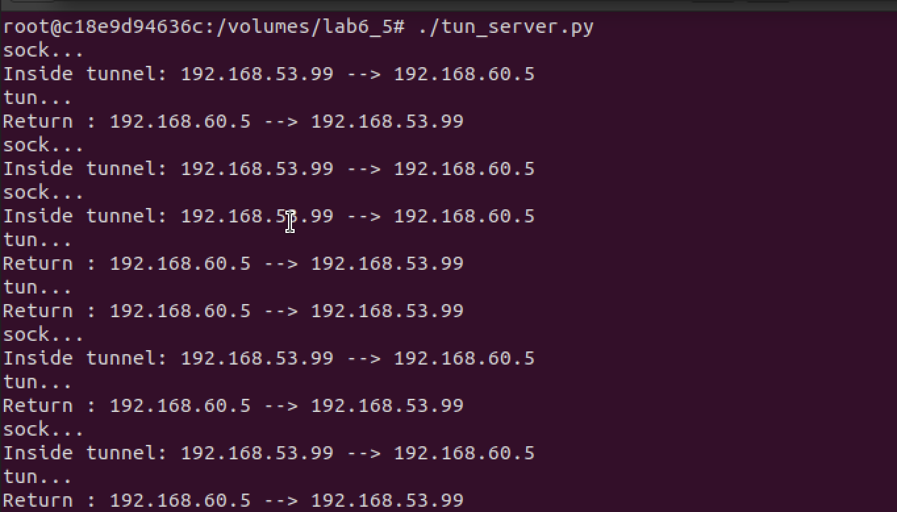

We break the tunnel by stopping the tun_server and try to type something in the telnet window. Nothing shows up.

We start the connection again as shown below.

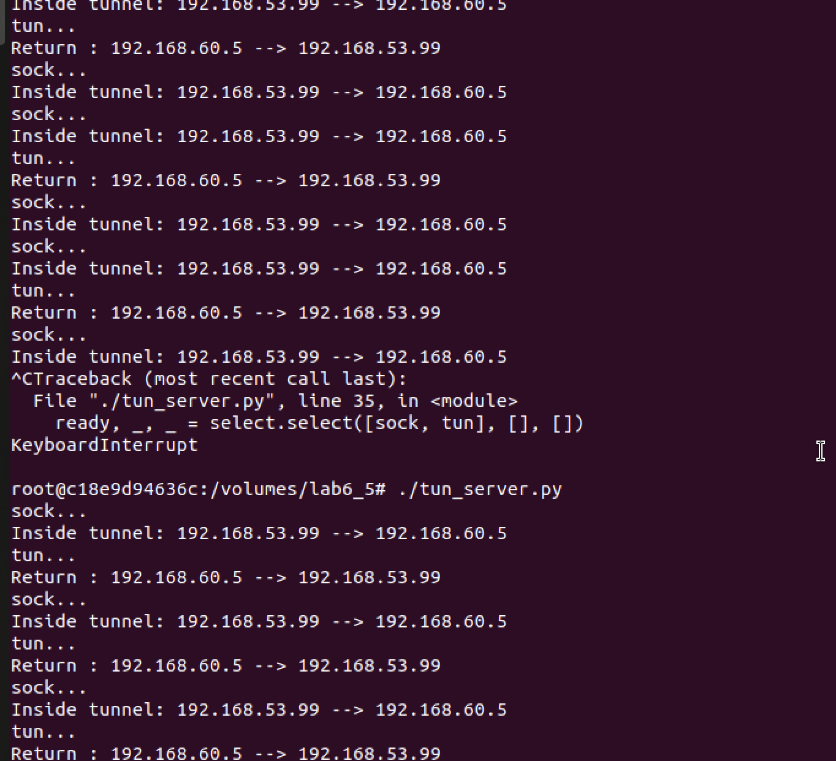

Breaking the connection and again reconnecting

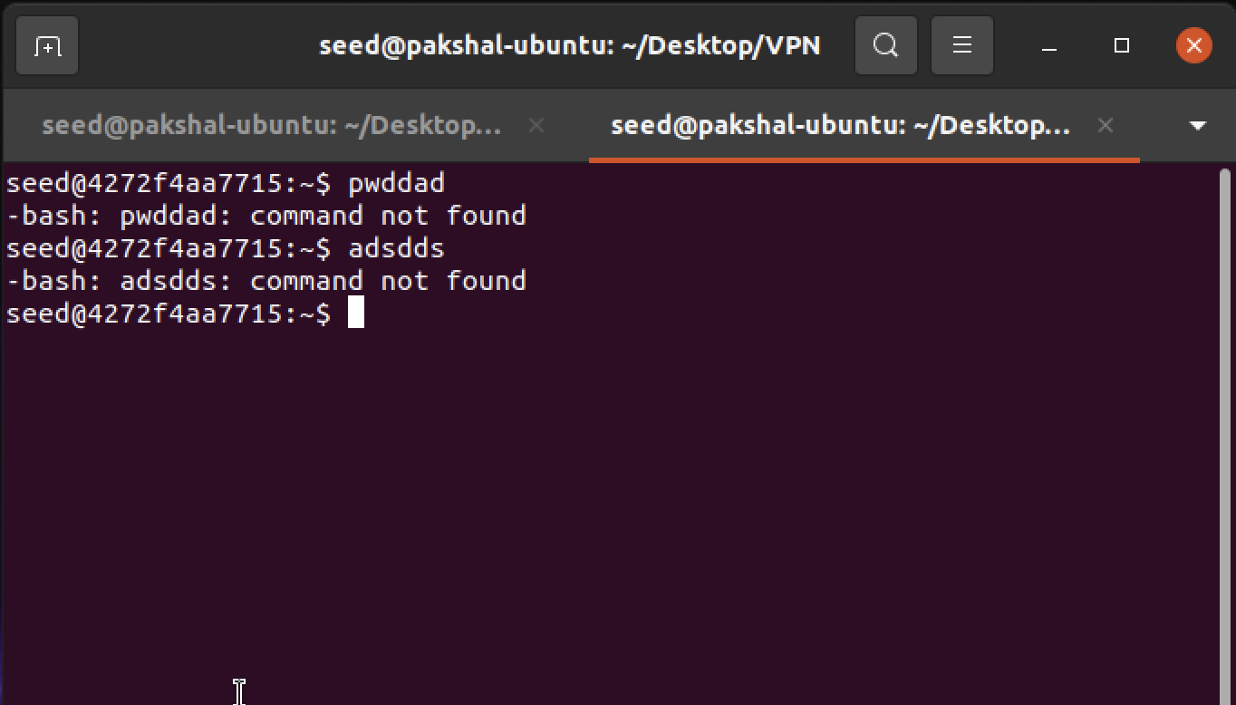

On telnet connection

We can see that whatever we had typed earlier now shows up on the telnet window. Thus, we have successfully broken the tunnel connection.

**Task 7:**

Here we need to delete the default route from Host V’s ip routing table, and add a custom route to 192.168.53.99.

The default route looks like this.

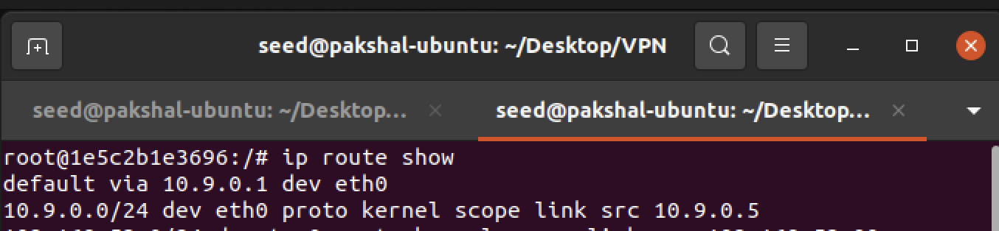

We delete the default route entry.



The default route has been deleted as shown above.

Now we add the custom routes.





We run tun_client.py and tun_server.py





We ping Host V from Host U to see if the route works or not.

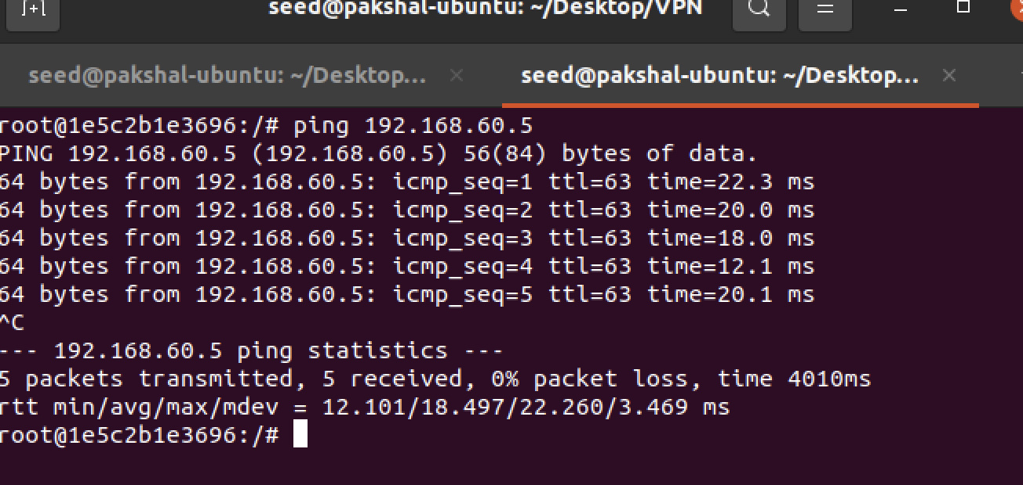

From the above we can infer that our route is working and the client and server looks like this.

